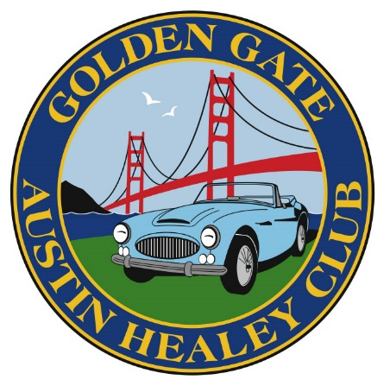
Golden Gate Austin Healey Club
Tour and Event Guidelines

Hosting a tour can be a lot of fun. In the process of putting your tour together you will find places and roads that you have never seen before. There are a lot of concerns that come up when you have decided to host a tour. We hope to help you in the process of hosting a tour with these guide line.
Remember that the tour guests are going to somewhere they may have never been to before so it will be an adventure for them. There are many of the tours I have been on in the past that were to new places that we have never seen, and later on we have visited them on our own.
- Destination
  - Select a location that you are familiar with and enjoy going to.
  - Once you have made a selection as to where you want to go. Make up a flier to send out to the membership a couple of months prior. Then in the last month have them send out to the membership once a week if your club uses e mail. This will keep the interest in the tour and every time a flier is sent out usually another person will sign up. Always include pictures in your flier

- Meeting spot
  - Select a meeting location that has enough space out of the away so that there is room for the general customers that are using the location.
  - Usually a Small Strip Mall, Mc Donald’s, Starbucks or something similar works the best
  - Go onto Google maps and find the meeting location and you can include a link to the meeting place in the flier for your tour.
  - Have a Gas Station near by
  - Leave on Time it is very easy to get behind on a tour so always build in a little extra time just in case. People will never be ready at your departure time no matter how many times you tell them. So if you say we are going to have a 15 minute bathroom stop. Be back in your car, engine running and start moving to let them know that they need to get going.
  - Remind people to fill up with gas before they arrive at the meeting location.
- Once you have the destination and meeting spot now is the time to put together a route to get to your destination.
  - Try to avoid major highways or freeways, unless it is only for a short distance.
  - Usually use as many back roads as possible, these are the roads that most people never use. So they will be seeing things that they usually do not see.
  - Have a bathroom stop after about 1 ½ hours of driving usually at the meeting spot people have drank several coffees and will need a stop.
  - Remember that all stops no matter if it is a gas stop, bathroom stop or lunch stop it will take a lot longer than you expect it to. Let people know how long the stop is, then get in your car and start pulling away slowly when you need to leave.
  - After a stop people are very slow about getting back in the car and moving again. You are on a schedule so get in the car start it up and start moving. People will hurry up and get moving.
  - *************
- Lunch Stops
  - Find some where unique that you wouldn’t usually go to.
  - Have the contact info for your lunch stop. Just in case something happens in route and you are late. Then you can call the restaurant and let them know.
  - Paying for the meals is always an issue, there are a couple of options.
    - Have a set menu and collect from everyone prior to the tour. You can select say 3 items off the menu about the same price. Have people pre pay and select a lunch.
    - Restaurants don’t like it but they can all have separate bills, just make as easy as possible on the restaurant.
    - Stop along the way for a picnic lunch. Be sure and tell people that they will need to bring their own lunch.
    - Have a picnic stop along the way. Collect from people prior to the tour. Then go to the store and make a picnic lunch for the group.
    - Parking needs are always an issue see if the lunch stop will block off some parking spaces for your group. Keeps the cars safe and also draws some attention to the restaurant.
  - If you stop at a winery or other such location that has tasting charges. Have people pay their own unless you can get the location to waive the charges for the group. One option is to pre purchase several bottles and arrange a private tasting. Also if stopping at a winery it is always a good idea to have some crackers and cheese to snack on while there.
  - Sometimes it is easier to collect for misc costs such as food, drinks, tasting fees, admission fees, etc. and to make things run smoother you can collect prior to the tour. This way there is only one person paying for the group.
- Maps and Instructions
  - Google Maps works the best you can plot out your route and print all the instructions.
  - Things happen in route. Drive the route a couple of weeks before your tour, make sure that there isn’t road work or other things that may have happened from when you first planned the tour.
  - Being the passenger sometimes can be boring, so give them something to do. You can put together an observation ralley. Giving them things to look for along the way.
  - There are several Triva things that can be put together for people to do along the way. We have used several and they are fun to review at a lunch stop or at get together before dinner on an overnight tour.
    - Misc questions about the Austin Healey
    - Misc questions about other people that are on the tour. This way people will start talking especially the new members
    - Misc questions about movies
  - Included is a sample of a 2 day tour that we have recently done.
- During the tour things to watch out for
  - Have radio contact with the front and rear cars, select someone who knows how to use a radio.
  - Travel with your headlight on.
  - Always keep the car in front and the car behind you in sight
  - If you loose sight of the car behind you slow down so they can catch up and not get lost. This will cause the car in front of you to slow down as well.
  - When going thru an area that has a couple of stop lights have a meeting location just past the area. The re grouping location should be an area that has enough space safely off the side of the road for all cars.
  - When pulling back on the road have the last car come out first, this will slow traffic and allow the group to pull out together.
  - In the route try to avoid crossing a major roads that do not have a 4 way stop. If you must have a spot where you can regroup after crossing the road drive slowly on the shoulder until the last car has passed thru the intersection.
  - As you get closer to the end of the tour people will drop off as they have to get home by another route.
  - If your tour goes late into the day especially on a Sunday most people will be ready to head home by about 2 pm.
- Overnight Tours
  - Hotel Reservations
    - Get a room block that you can hold until about 1 week prior to the tour.
    - Tell people that your cutoff date is about 3 or 4 days before the actual cutoff date.

  - Dinner Reservations
    - Find a cute unique place that you wouldn’t usually go to.
    - Always try to have the restaurant do separate bills for a dinner stop.
- Social events
  - Christmas Party
    - Plan early places start booking for these events in June and July
  - Season Openers
    - Usually in March / April depending on the weather in your area.
    - Find a small winery, brewery, restaurant that can host the group for a brunch. Then plan a short tour after.
  - Tech Sessions
    - Usually in January, February works best people are working on their cars getting them ready for the next season.
    - Find a local shop that knows the cars and see if they can host an event. Maybe get a car up on the hoist and have a professional mechanic show you around the car. One of the best attended tech sessions I had was a Healey transmission in pieces and showed the inner workings of the transmission and overdrive.
    - Or if a member has a large enough garage you could have something there.
  - Ice Cream Social Events

  - Misc Social Events

