

Rendezvous Guide


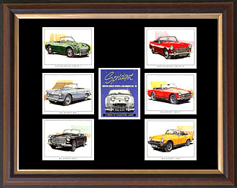

Created by: Jan Saxon and Lois Buhman
Cascade Austin Healey Club of Washington
Table of Contents

1 Overview: 2
2 What does it take to put on a Rendezvous? 2
3 Timeline: 3
4 Site Selection: 4
5 Leadership and Responsibilities: 6
5.1 Chairperson(s) 6
5.2 Activities Committee Lead 6
5.3 Regalia Committee Lead 7
5.4 Auction Committee Lead 7
5.5 Registration Committee Lead 8
5.6 Popular Choice Car Show and Awards Committee Lead 8
5.7 Concours Committee Lead 9
5.8 Financial Committee Lead 9
5.9 Communications Committee Lead 9
5.10 Public Relations Committee Lead 10
5.11 Welcoming Committee Lead 12
6 Attachments – Samples ..............................................................................13

7 Helpful Hints………………………………………………………………………………………………………32

8 Lessons Learned:

8.1 2007 Cascade Austin Healey Club of Washington……………………………………………35

8.2 2009 Golden Gate……………………………………………………………………………………………..37

  - 2010 Oregon Austin Healey Club………………………………………………………………………43

  - 2011 Cascade Austin Healey Club of Washington…………………………………………….48

8.5 2012 Austin Healey Owners Association of British Columbia……………………………49

Overview:
This notebook was put together after the 2007 Rendezvous in Richland WA. It is meant to be a helpful guide to the chairperson(s) and committee heads organizing the Austin Healey Rendezvous. It is NOT meant to be a prescription for how to organize a Rendezvous.

It is our hope that those who organize meets in the future will keep the notebook current by adding information they deem helpful for those who will follow.

What does it take to put on a Rendezvous?

Chairperson (s) with experience of working on a Rendezvous before or attending meets.
Deciding on the date of the meet. Take weather into consideration.

Location

- A three or four-star hotel with enough rooms 100+.
- A room price that is affordable by the majority of attendees.
- Safe parking with no or low speed bumps.
- Venue for the popular choice car show that is close to the hotel.
- Catering availability.
- What comps the hotel will give.

Committees

- Activities
- Regalia
- Auction
- Registration
- Popular Choice Car Show and Awards
- Concours
- Financial/budget
- Public Relations/communications/logo
- Welcoming

Timeline:

1 ½ to 2 years prior to the meet:

- Chairperson (s) need to be selected.
- Select committee heads. (See Section: 5 Leadership and Responsibilities:) for a list of committees and responsibilities.
- Determine the date of the meet.
- Site selection.
  - Ask club members to make recommendations for a location. Each person making a recommendation uses the site selection worksheet to gather information.
  - Set a meeting date reports on location recommendations.
  - After members have heard the recommendations, have a vote on the location preference. It might be a good idea to have a 2nd location preference in case you incur a problem with the first one.

After Site Selection:
- Design the logo.
- Set the budget.

1 Year prior to the meet:
- Select Regalia
- Design the registration form
- Send the form to clubs and magazines
- Set up the computer for registrations
- Begin to accept and record registrations

6 Months prior to the meet:
Activities finalized
Registration packets developed
Name tags designed and printed
Popular Choice car show finalized
Opening welcome party organized-food ordered.
Start collecting auction items and inventory them on spreadsheet.

Site Selection:
The following pages contain an example for a worksheet for site selection.
*************************************
Worksheet for site selection – Page 1

Rendezvous Year: ________________

Possible Date(s) for Rendezvous: ___________________________________________

Submitted by: ___________________________________________________________

Date of hotel visitation: ____________________________________________________

Suggested location: _____________________________________ (city or located near)

Hotel name: _____________________________________________________________

Contact person: __________________________________________________________

Phone number: __________________________________________________________

Reasons for selecting this location:
_______________________________________________________________________
_______________________________________________________________________
_______________________________________________________________________
_______________________________________________________________________
_______________________________________________________________________
_______________________________________________________________________
_______________________________________________________________________
_______________________________________________________________________
_______________________________________________________________________
_______________________________________________________________________
_______________________________________________________________________
_______________________________________________________________________
_______________________________________________________________________
Worksheet for site selection – Page 2

Hotel Requirements:

___ Does the hotel have availability between the dates specified.
___ Does the hotel require a deposit? How much? __________
___ Is the hotel at least a three star rating?
___ Does the hotel have at least 100+ rooms?
___ Size of rooms and amenities: bed size, refrig, iron, coffee pots
___ Is the cost of a double occupancy room between $75-100+?
___ Does the hotel have safe parking?
___ Does the hotel have speed bumps in the parking lot?
___ Is the hotel located in a low traffic area?
___ Is there a room for the first night registration and party? Should be able to hold between 125 to 250 people.
___ Is there a charge for the room use? ____________
___ Is there a room for the auction? Should be able to hold between 125 to 250 people.
___ Is there a charge for the room use? ___________
___ Does the hotel have a willingness to work with the club?
___ Is the hotel offering any comps? (free rooms depending on certain number of booked rooms, free use of room for registration)
___ Does the hotel have catering availability?
___ If not, can they recommend anyone?

Area Requirements:

___ Is the city/town willing to work with the club?
___ Is there a good area for the popular choice car show? (Close to hotel, has a grassy area for parking of cars, shade, area for a barbecue/picnic)
___ How is the weather that time of year?
___ Are there varied attractions in the area?
- Shopping
- Tour possibilities
- Wineries
- Water attractions
- Museums
- Casinos
- Other

Comments:

Leadership and Responsibilities:

Chairperson(s)
- Ensure integrity of Club throughout the length of meet
- Selection of committee chairs
- Work with different sub committees
- Overseeing projects completed on time
- Schedule meetings with sub committees to keep everyone updated on progress and needs.
- Responsible for overall club’s financial success and meet
- Coordinate with other clubs and associations
- Oversee site selection and hotel selection
- Negotiate items for contract, sign when all are in agreement
- Coordinate with hotel, catering and other suppliers/vendors
- Meet deadlines
- Keep receipts for Finance to be reimbursed
- Name tag holders, name tags printed, printed schedule of events for tag holders
- Use non-profit tax ID # for any purchases

5.2 Activities Committee Lead
- Committee lead will work with the chairperson(s)
- Recruit volunteer staff if needed
- Coordinate different activities for meet such as:

- Organized driving tours both guided & self-guided
- Activities/games/events
        - Bunko
        - Poker
        - Golf
        - Healey oil painting
        - Funkana
        - Arts and Crafts

- Assist in setting agenda for meet
- Meet deadlines
- Keep receipts for Finance to be reimbursed
- Use non-profit tax ID # for any purchases
- Clean up area at hotel when done

5.3 Regalia Committee Lead
- Committee lead will work with the chairperson(s)
- Recruit volunteer staff if needed
- Work with Communications/Promotions to acquire logo
- Research Regalia item costs; acquire samples to bring to Committee review
- Work with Registration Committee to get accurate information on registration form
- Work with vendors
- Organize and maintain pre-orders
- Responsible for delivery of all items to the meet
- Responsible for keeping items safe and clean
- Setup for Regalia sales and pre-order distribution
- Meet deadlines
- Keep receipts for Finance to be reimbursed
- Use non-profit tax ID # for any purchases
- Clean up area at hotel when done

5.4 Auction Committee Lead
- Committee lead will work with the chairperson(s)
- Recruit volunteer staff if needed
- Communicate need for auction items with hosting club and other clubs
- Communicate need for item delivery or description prior to meet
- Inventory items
- Prepare master list of auction items
- Prepare master list of silent items
- Prepare necessary forms for sold items
- Setup auction items at meet
- Set up payment system for end of auction (several tables for check out. Have a cash line and credit line.)
- Bidding paddles
- Sign with time posted to view items. Preview time could be put on activity sheet w/name tag
- Contact Finance Chairman for use of credit card machine
- End of auction report for Finance Chairman of amount made
- If doing a raffle, work raffle drawings into auction
- Meet deadlines
- Keep receipts for Finance to be reimbursed
- Use non-profit tax ID # for any purchases
- Clean up area at hotel when done

5.5 Registration Committee Lead
- Committee lead will work with the chairperson(s)
- Recruit volunteer staff if needed
- Design registration form
- Coordinate with other committees for their information that is need on the registration form ~~ Regalia and Communications
- Receive and process registration
- Maintain record of registrations and paid activities
- Ensure prompt forwarding to finance committee for deposit
- Assist in design and production of Registration forms, nametags and program
- Keep up to date on info to forward to Popular Choice Committee
- Meet deadlines
- Keep receipts for Finance to be reimbursed
- Use non-profit tax ID # for any purchases
- Clean up area at hotel when done

5.6 Popular Choice Car Show and Awards Committee Lead
- Committee lead will work with chairperson(s)
- Recruit volunteer staff if needed

Car Show
        - Signs for directions to car show field
        - Signs for class parking at car show
        - Design and produce ballots for car show
        - Counting of ballot forms
        - Be sure sprinklers (if any) are turned off

Popular Choice
        - Maintain up to date registration info
        - Work with registration committee

Awards
        - Ensure right number of awards are ordered
        - Disburse awards at end of car show or at banquet dinner.
        - Work with vendors on design and purchase awards for:
          - Popular choice
          - Best in Show
          - Auto Cross
          - Rally
        - Solicit sponsors for trophies, include their name on trophy
        - Meet deadlines
        - Keep receipts for Finance to be reimbursed
        - Use non-profit tax ID # for any purchases
        - Clean up area when done

5.7 Concours Committee Lead
- Committee lead will work with the chairperson(s)
- Recruit volunteer staff if needed
- Work with national committee to acquire all necessary forms and info for concours
- Communicate cost to registration committee
- Set up time and place for judging
- Enlist club members, either from hosting club or other clubs for assistance with judging.
- Be available for inquiries from prospective entrants
- Be at registration for prospective entrants questions
- Ensure prompt disbursements of information to entrants
- Contact Nat’l committee representative to be sanctioned
- Meet deadlines
- Keep receipts for Finance to be reimbursed
- Use non-profit tax ID # for any purchases
- Clean up hotel area when done

5.8 Financial Committee Lead
- Committee lead will work with the chairperson(s)
- Recruit volunteer staff if needed
- Maintain separate accounting for all meet requirements
- Acquire best rate for credit card use
- Manage budget and report financial status
- Disbursement of funds when requested
- Meet deadlines
- Keep receipts for reimbursement

5.9 Communications\Logo Committee Lead
- Committee lead will work with the chairperson(s)
- Recruit volunteer staff if needed
- Design and produce logo for meet including brochures, activity signs, regalia, nametags and all other logo needs
- Meet deadlines
- Keep receipts for Finance to be reimbursed
- Use non-profit tax ID # for any purchases

5.10 Public Relations Committee Lead
- Committee lead will work with the chairperson(s)
- Design and produce log for meet including brochures, activity signs, regalia, nametags and all other logo needs.
- Recruit volunteer staff
- Start promoting the meet as soon as possible
- Flyer ready to pass out at meets
- Registration form will be out shortly after the first of year
- Email the information sheet and registration form to clubs.
*Example below
- Update web page and magazine with information on meet\ Meet deadlines
- Keep receipts for Finance to be reimbursed
- Use non-profit tax ID # for any purchases
- List of all contacts for future use: Name E-mail address Phone Number
- Contact: Club USA Club America
- Important to contact person in charge of writing articles for Calendar/and/or/magazine and ask if he/she will include information on the meet. Ask if possible to post information each month in magazine.

**Clubs: A H Club of America on west coast
OR CA (really want to see support here) Canada
Montana Idaho Nevada Texas
Others you consider important

**REALLY IMPORTANT Be sure you have contacted the right person at the respective club. Suggest a contact President and Vice president to be sure information is received and passed on. Follow up with a phone call to be sure the information is received.
*Some contact info below

Example of email sent in 2007
***********************************************************
Cascade Austin Healey Club is organizing the 2007 Rendezvous

The meet will be held July 16th-20th at the Shilo Inn on the
Columbia River in Richland, WA.

Attached are the registration form and activity sheet, which is ready for distribution. Please post on your website and in your magazine.

The registration form can also be downloaded from our website.

Pictures of the Regalia and order form along with other information about Rendezvous 2007 can be found on the Cascade Austin Healey Club of Washington’s web page.
http://cascadeahc.homestead.com/home.html

If you have any questions regarding the meet, contact one of the co-chairs listed below.

Jan Saxon
jksaxon@aol.com
253-939-2723

Lois Buhman
neilandlois@comcast.net
425-228-2742

***********************************************************

Contact Rendezvous Council clubs to get current listing of club officers:
The Golden Gate Austin Healey Club http://www.goldengatehealeys.com/
Austin Healey Club of San Diego http://sdhealey.org/
Austin Healey Association of Southern California http://www.austin-healey.org/
Oregon Austin Healey Club http://healey-oregon.org
Cascade Austin Healey Club of Washington http://cascadeahc.homestead.com/home.html
Austin Healey Owners of British Columbia http://www.healeys.ca/

5.11 Welcoming Committee Lead
- Committee lead will work with the chairperson(s)
- Recruit volunteer staff if needed
- Greet each car with cold water
- Show where to park
- Show where information on meet will be posted
- Show where meet registration can be found
- Show where the elevator is located
- Meet deadlines
- Keep receipts for Finance to be reimbursed
- Use non-profit tax ID # for any purchases

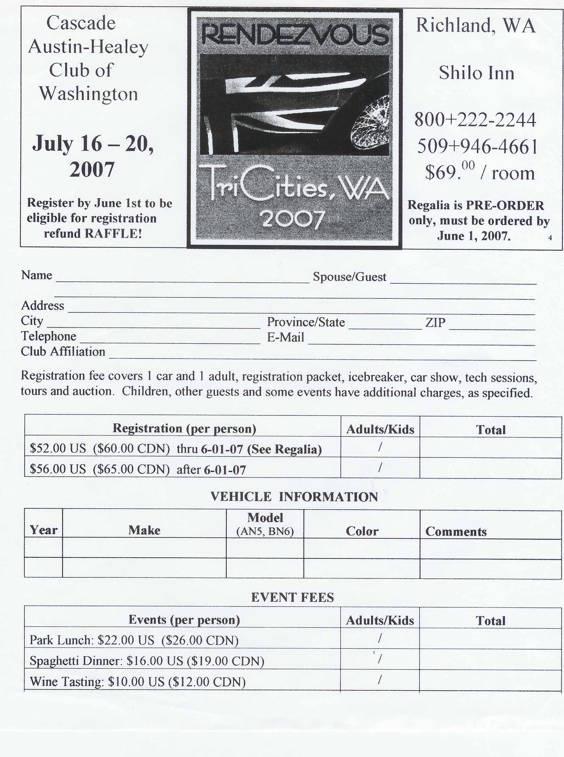

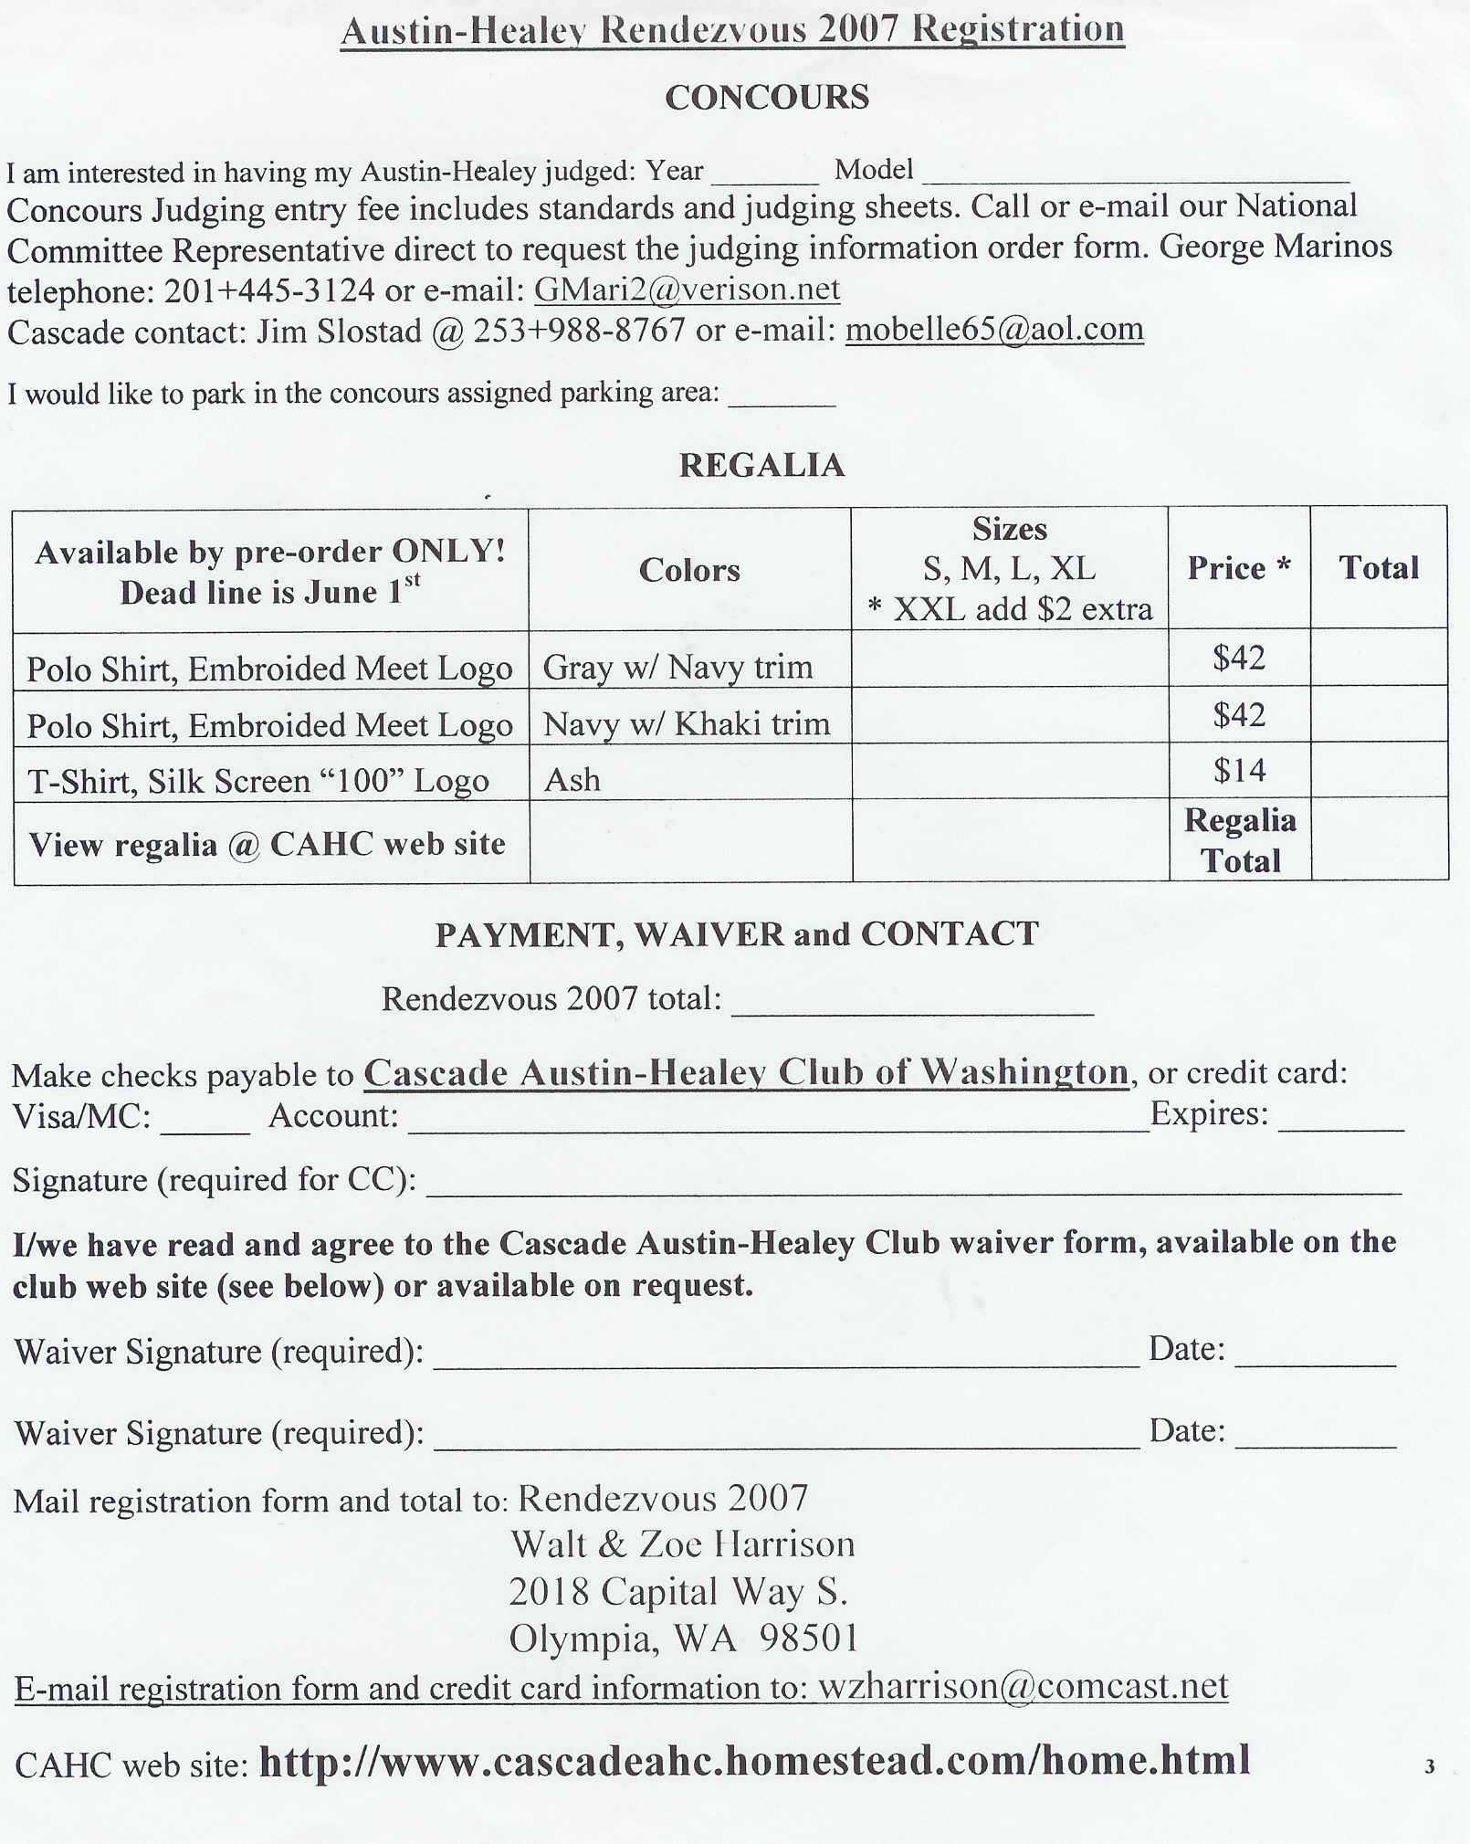
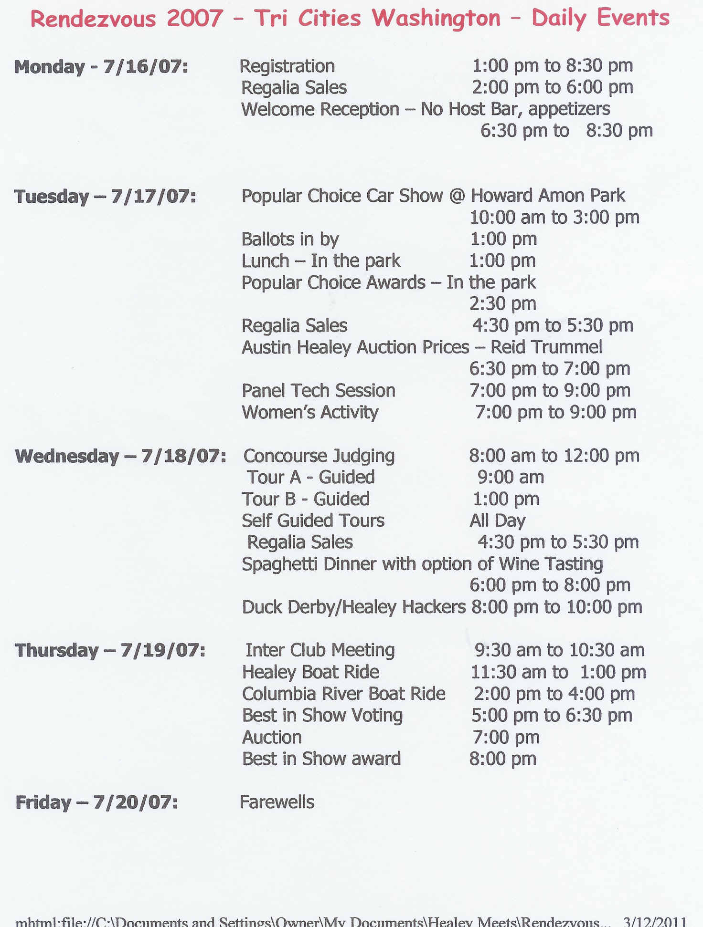
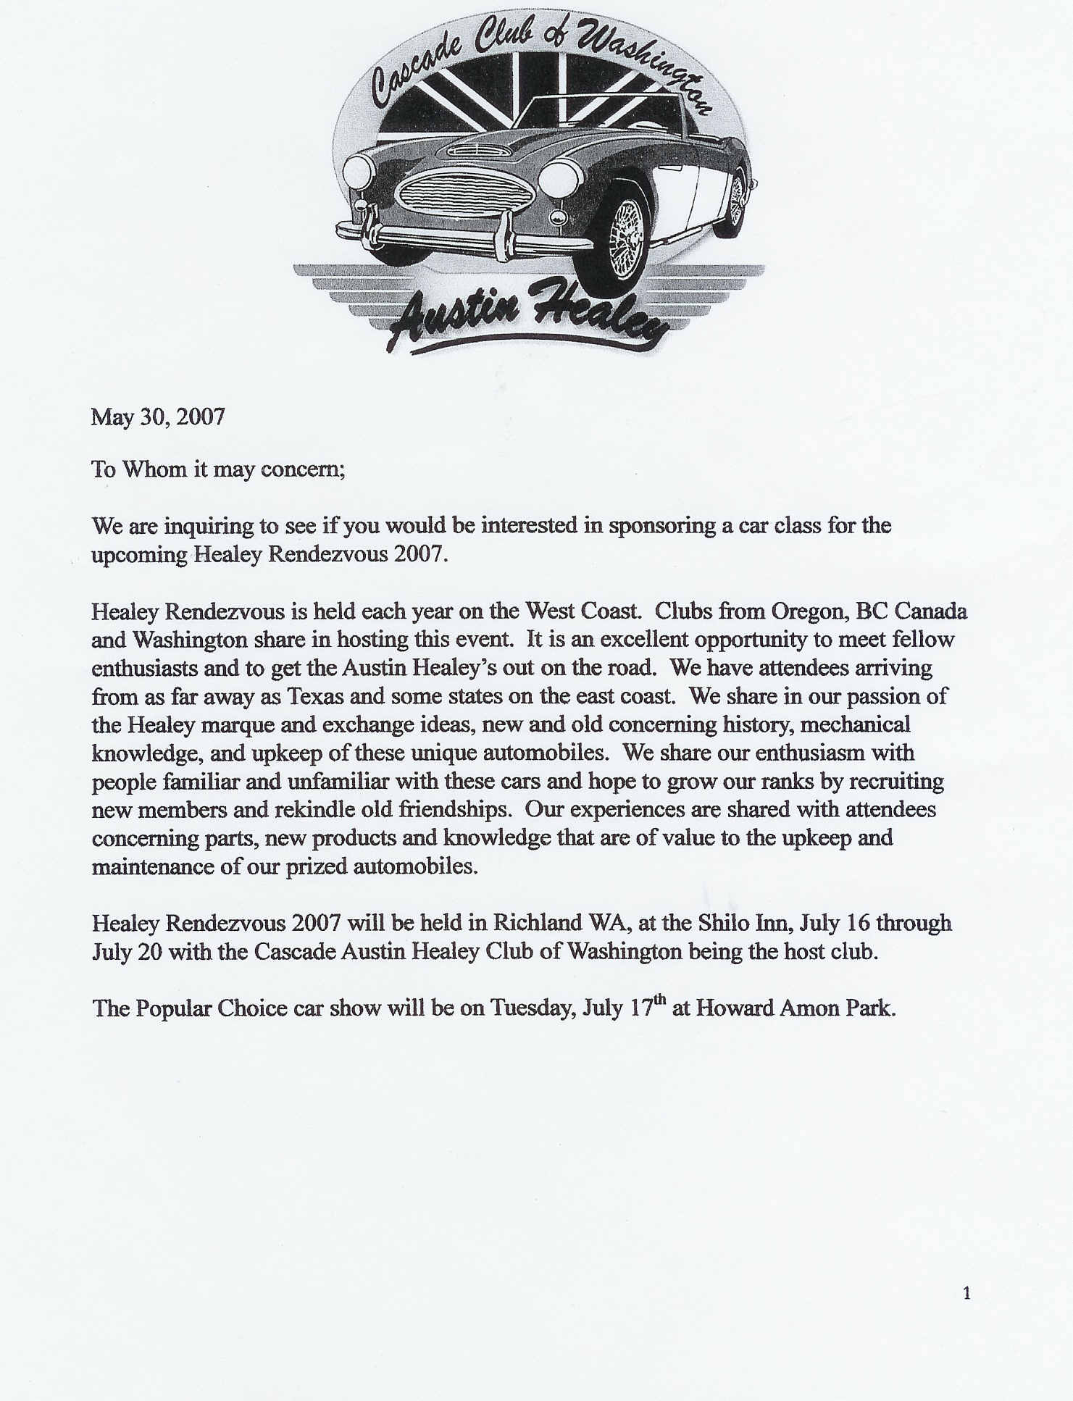
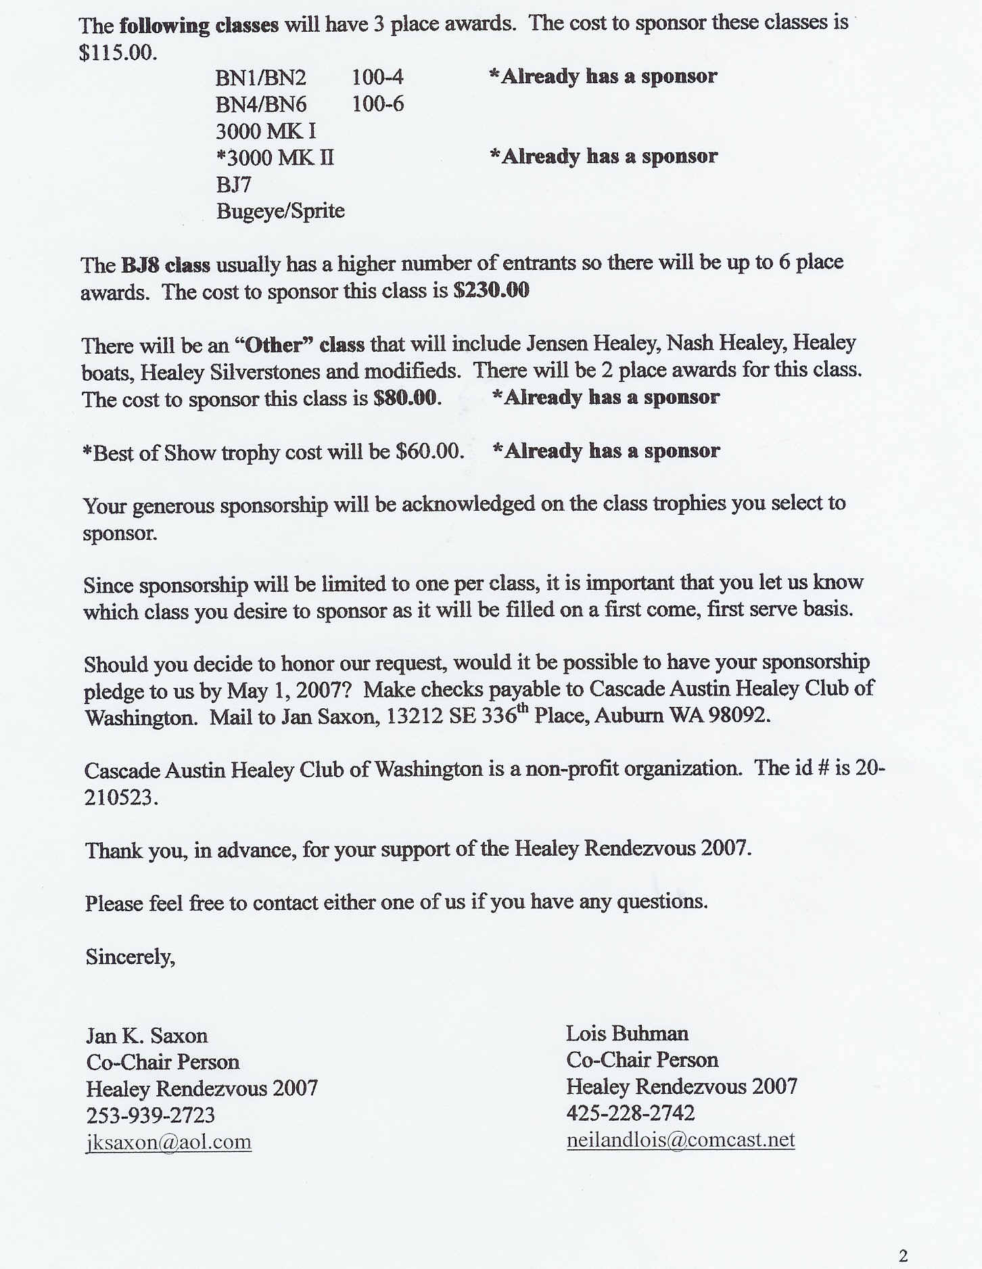
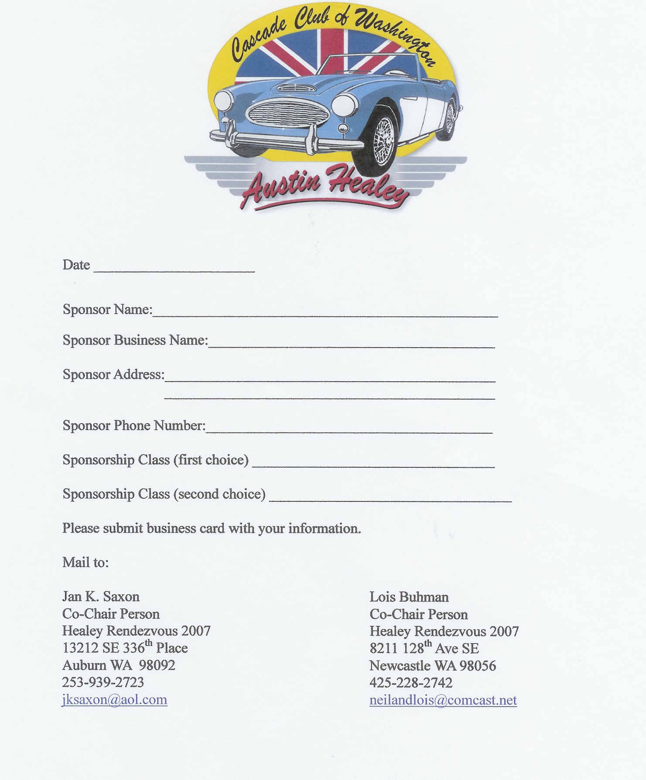

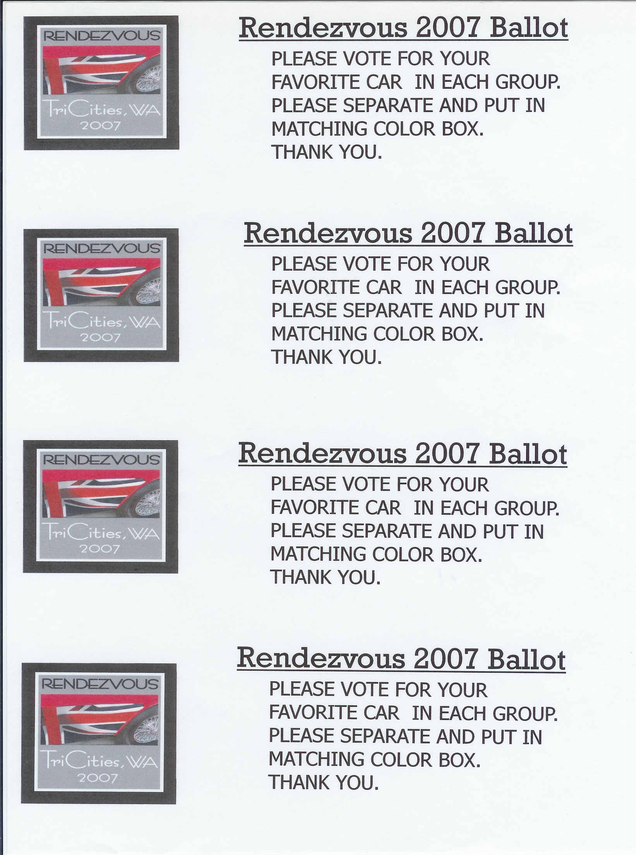
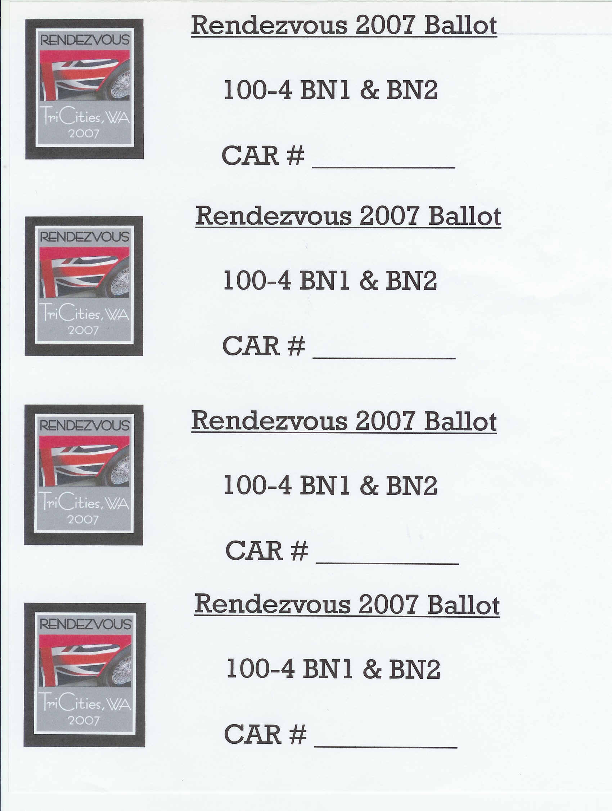
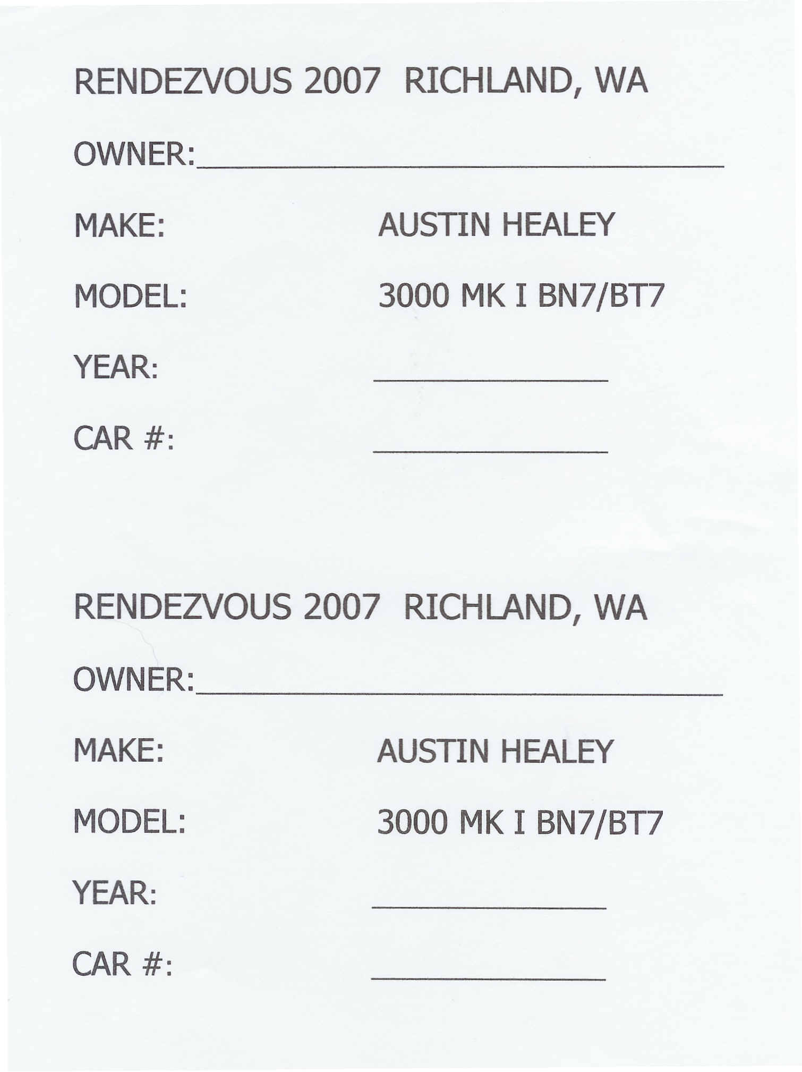
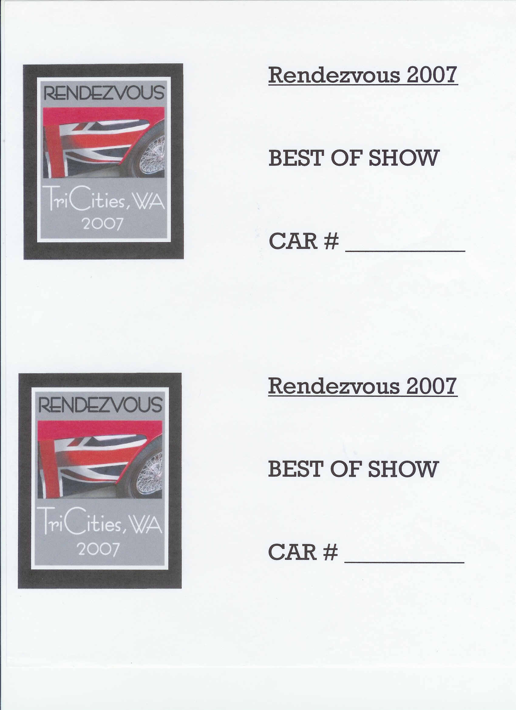
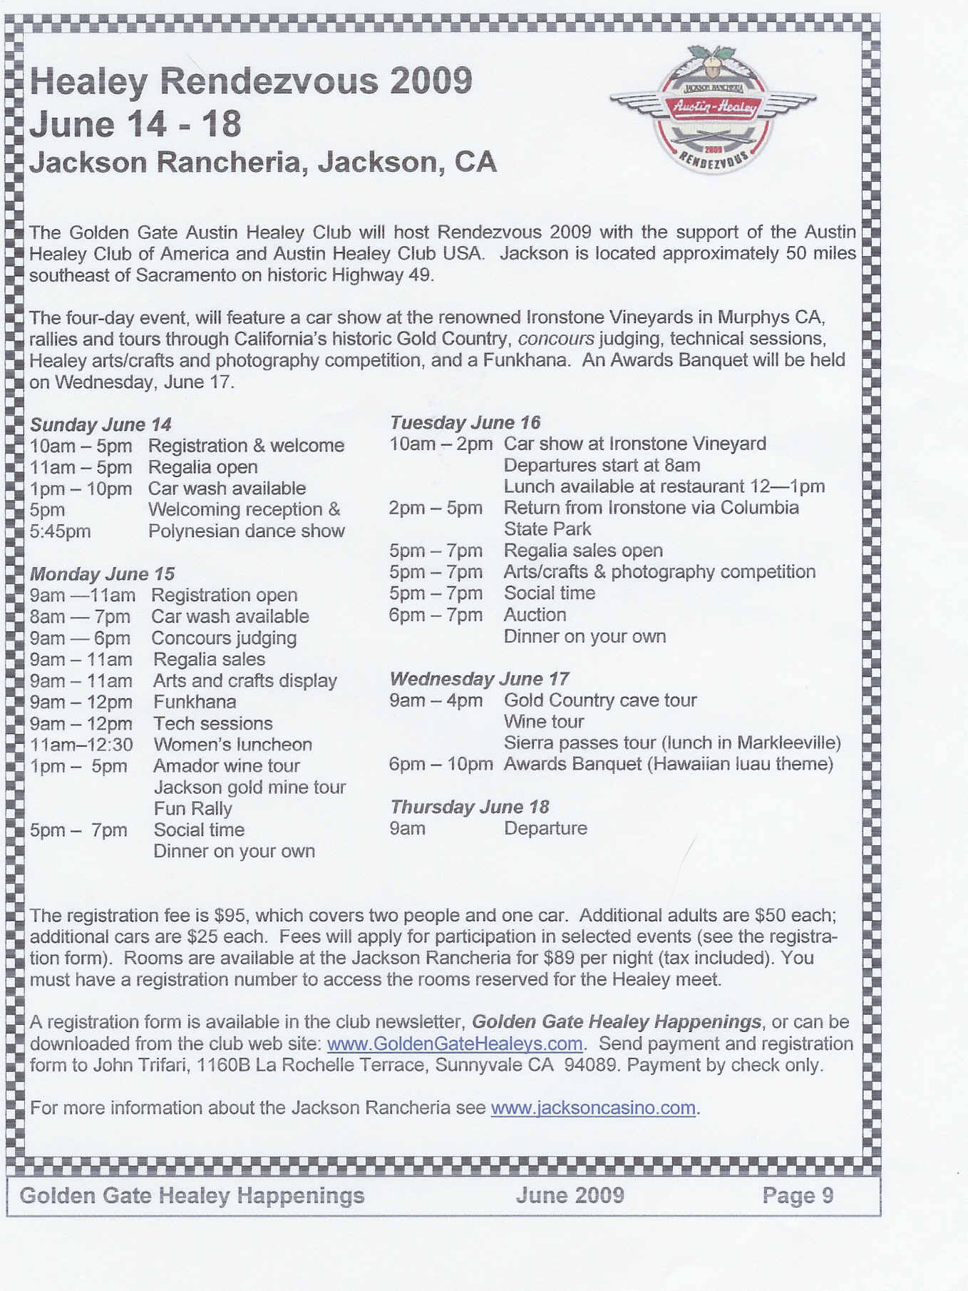
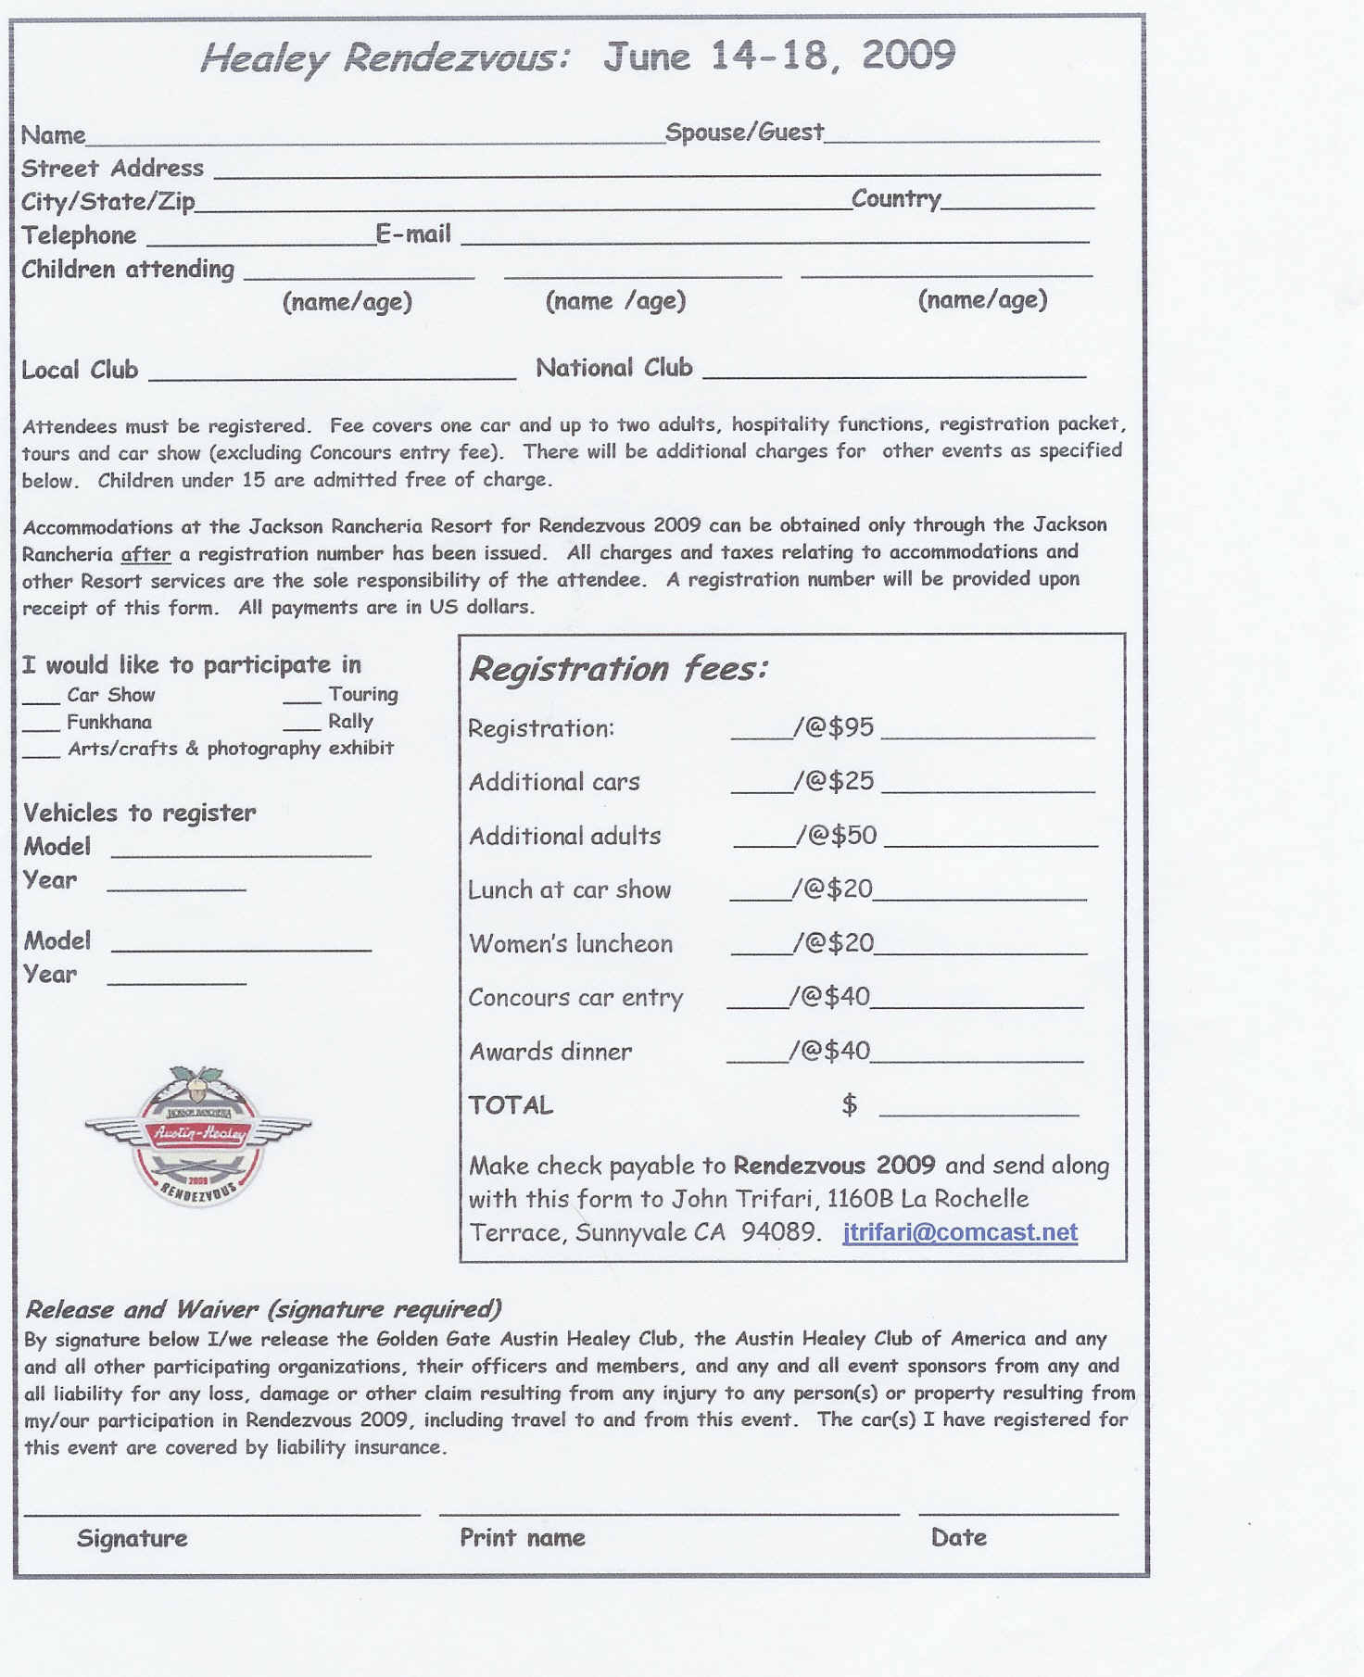
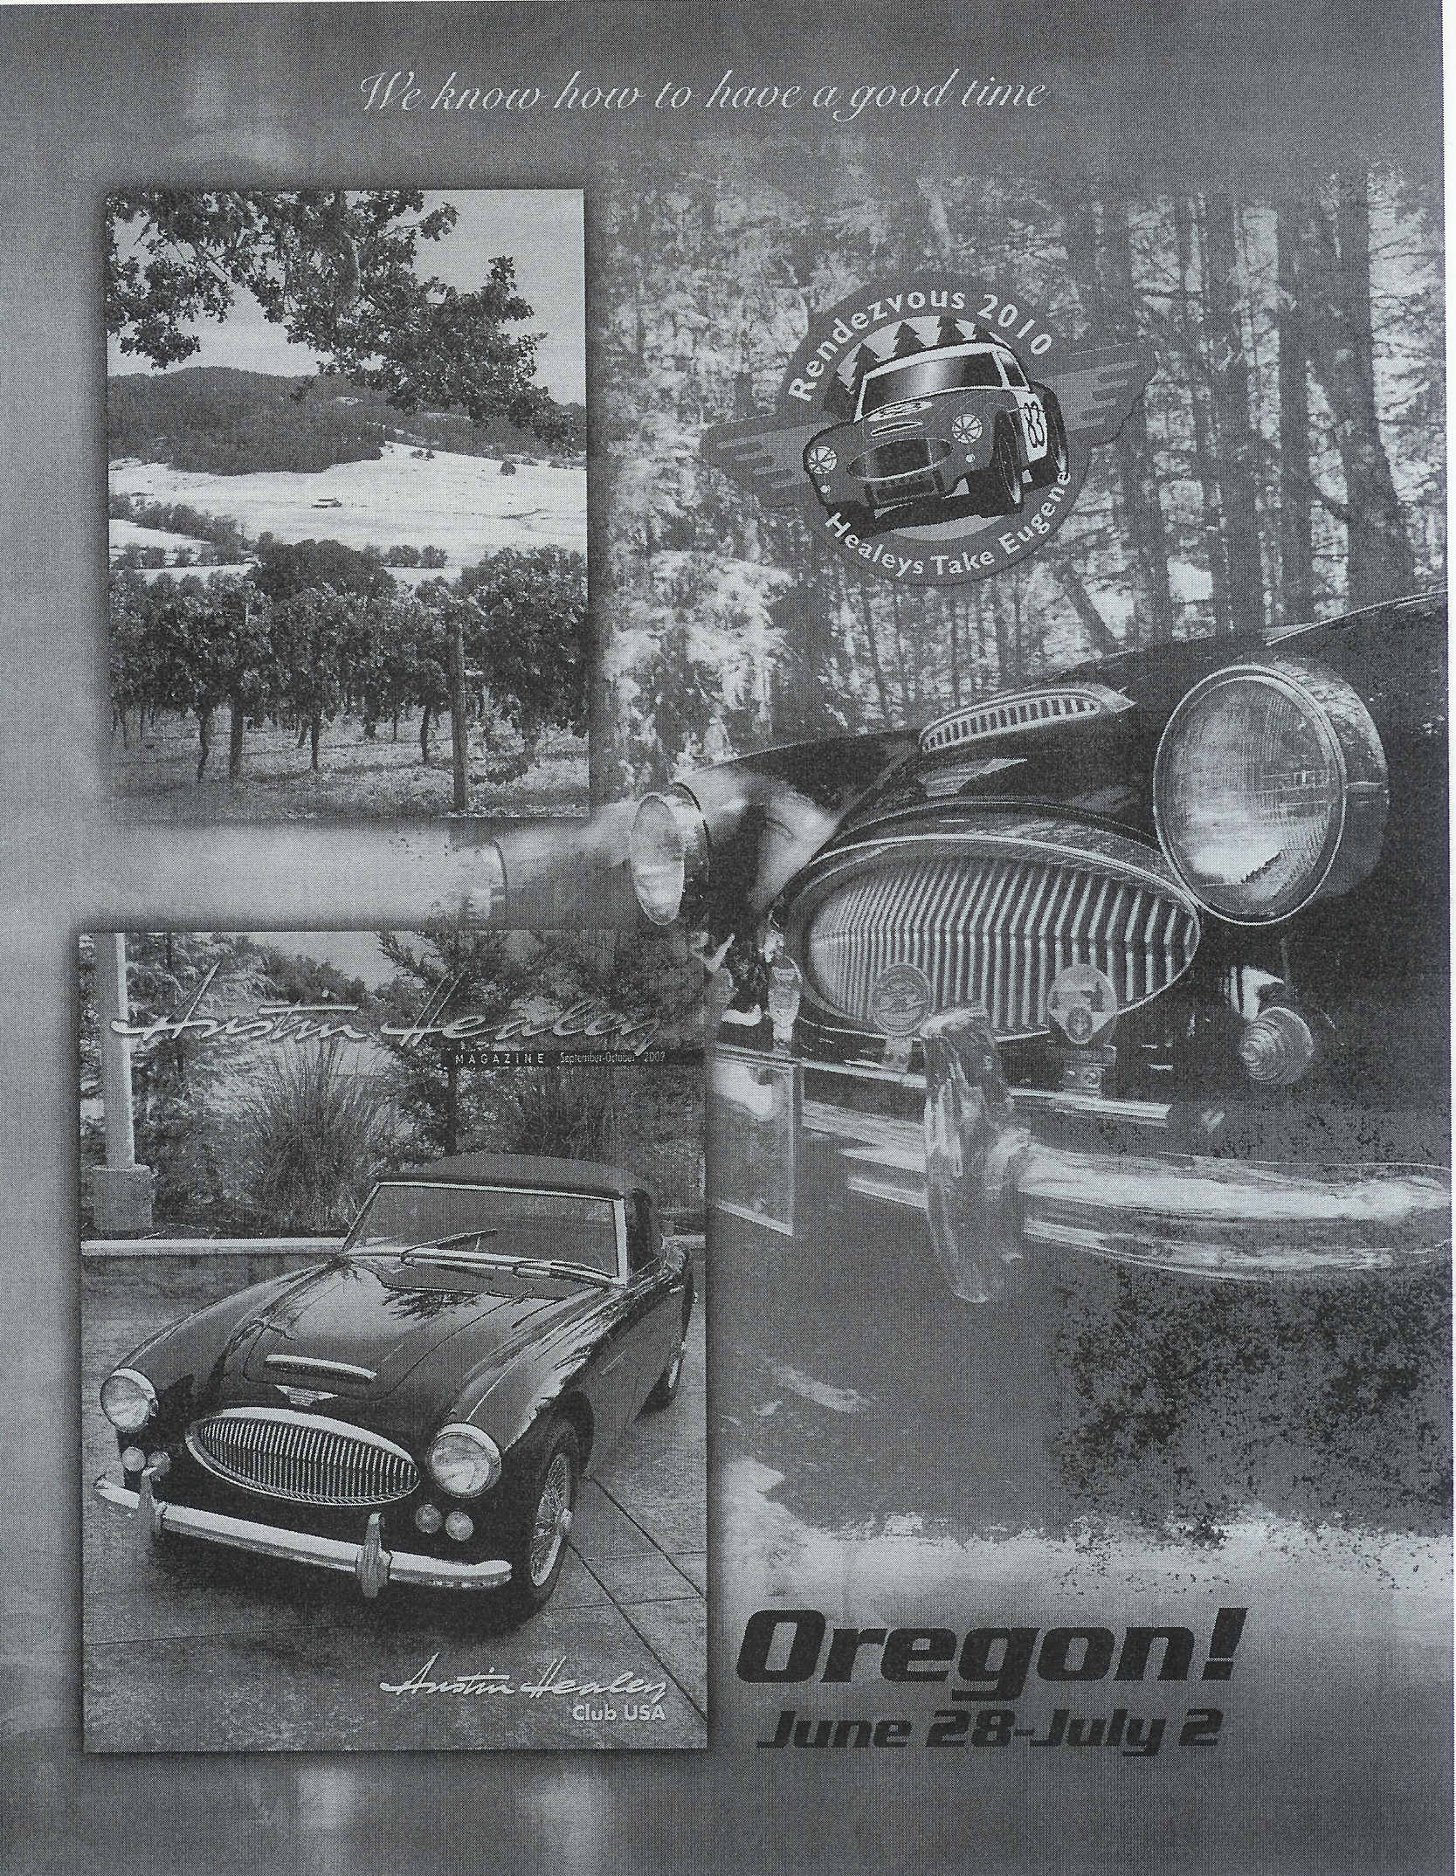
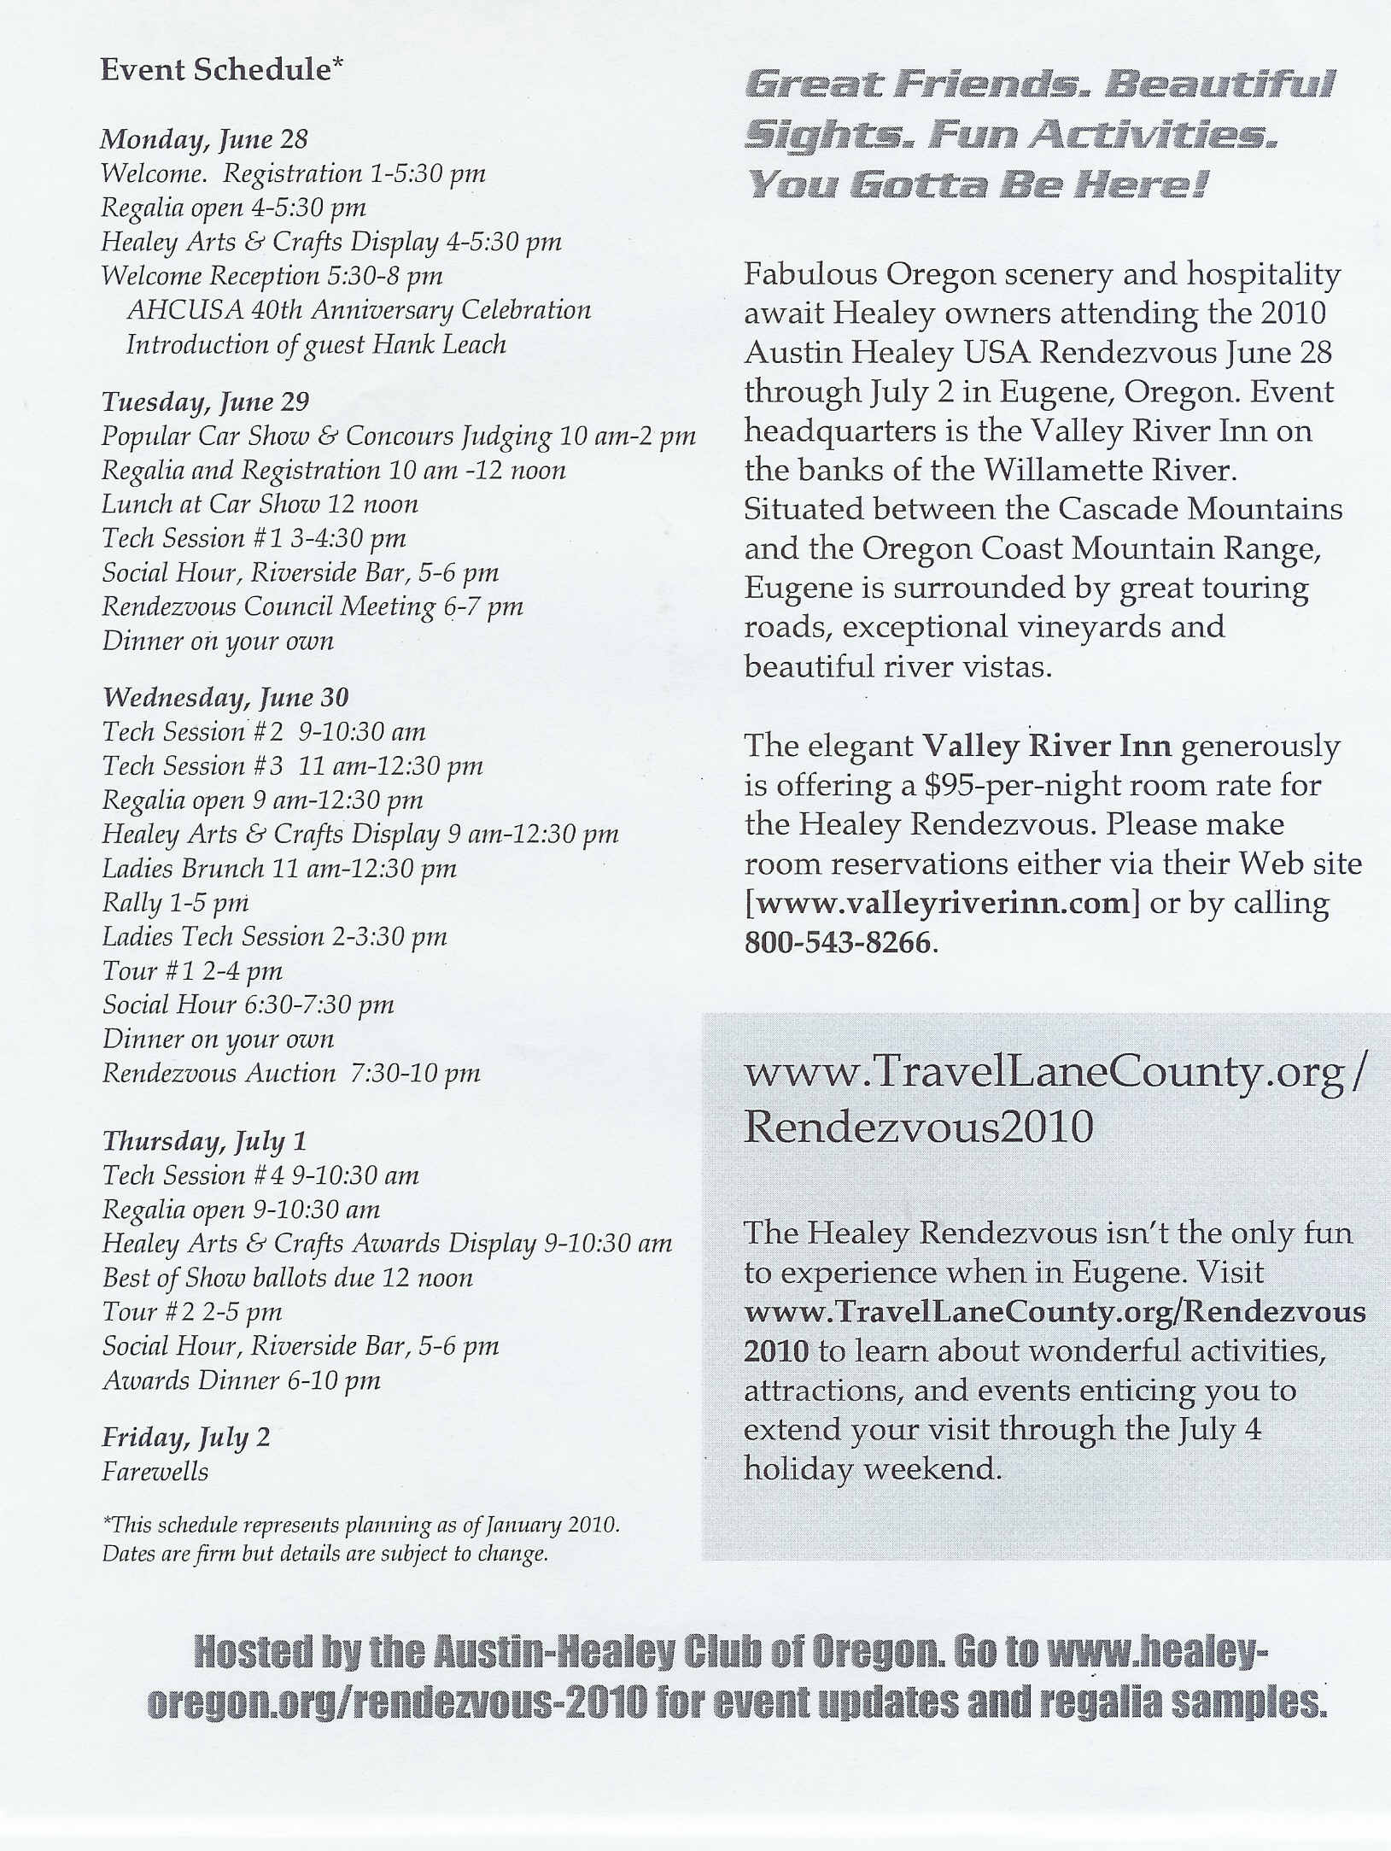
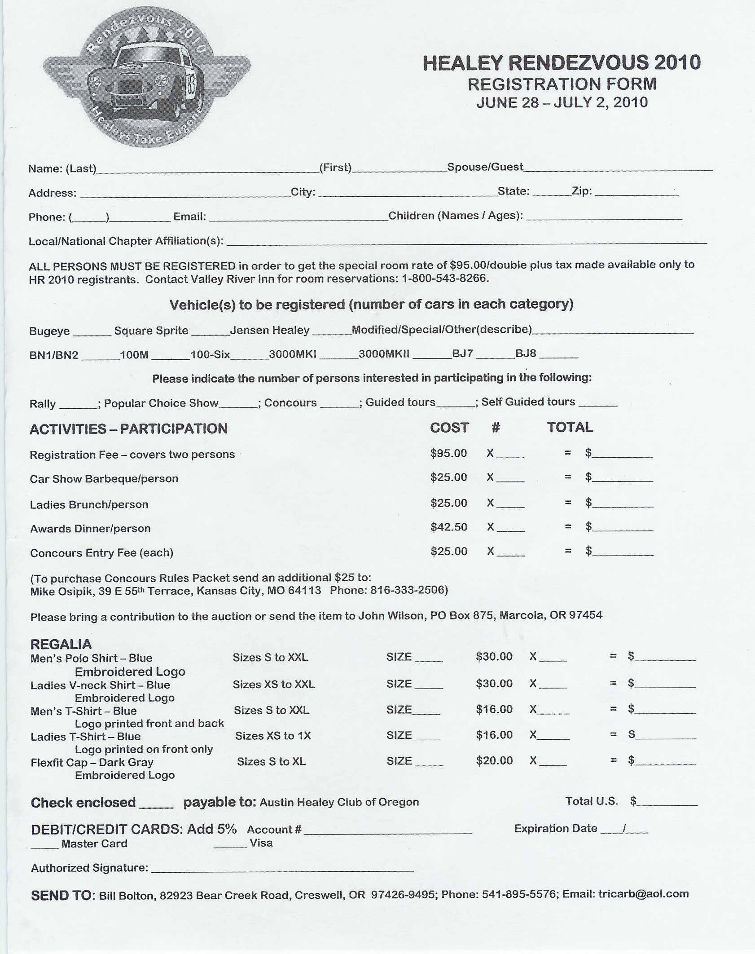

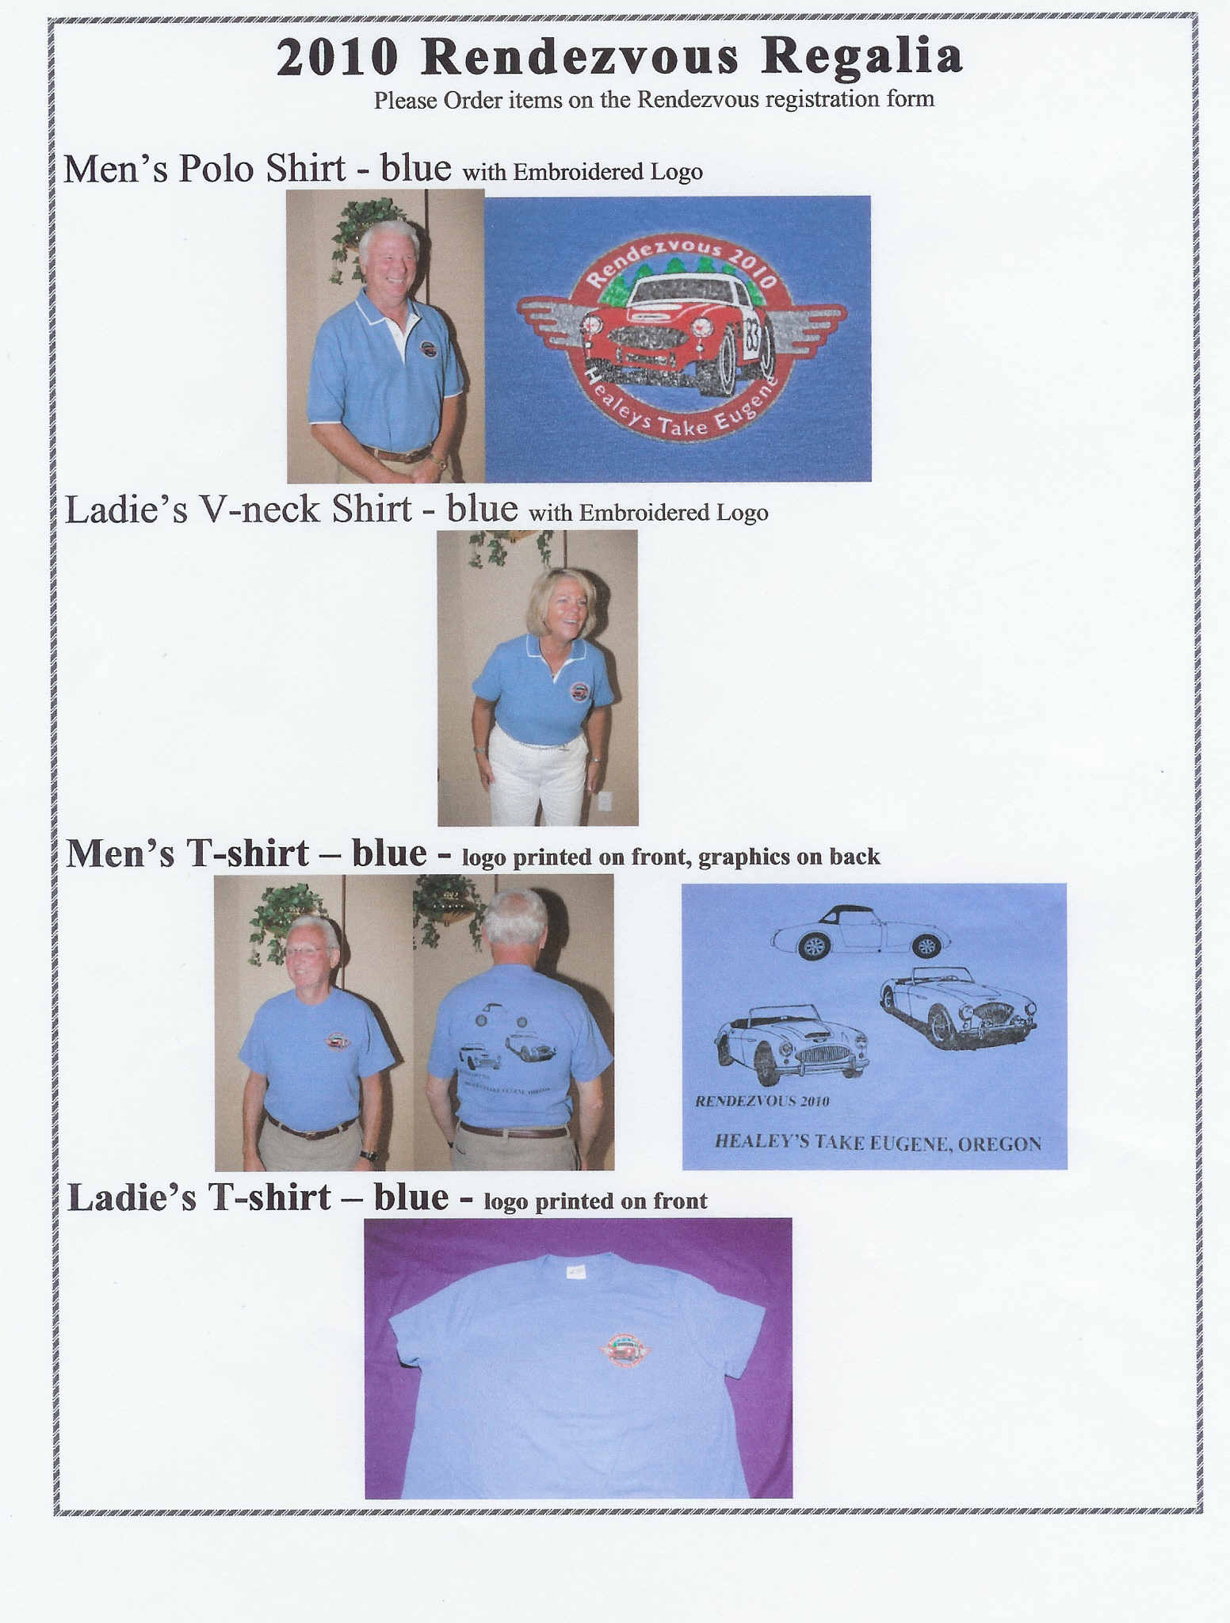
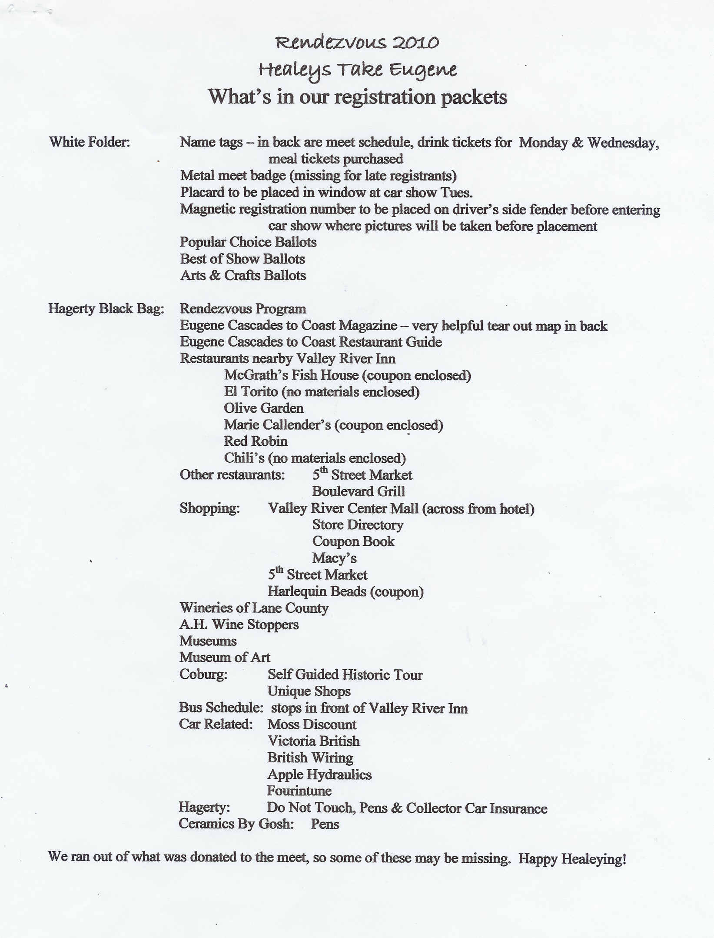
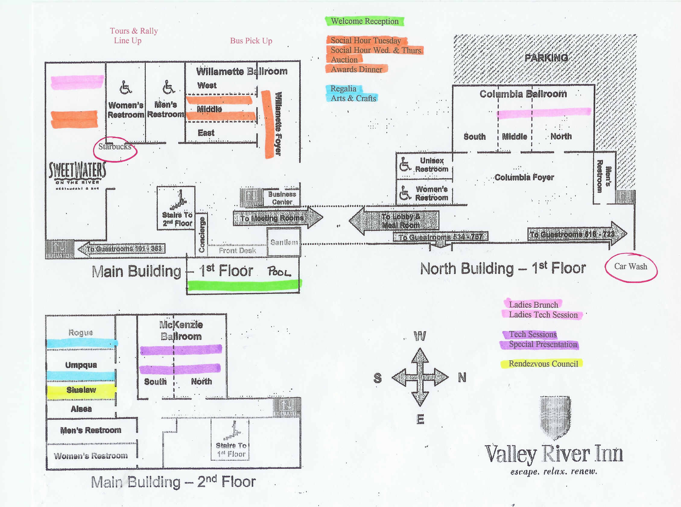

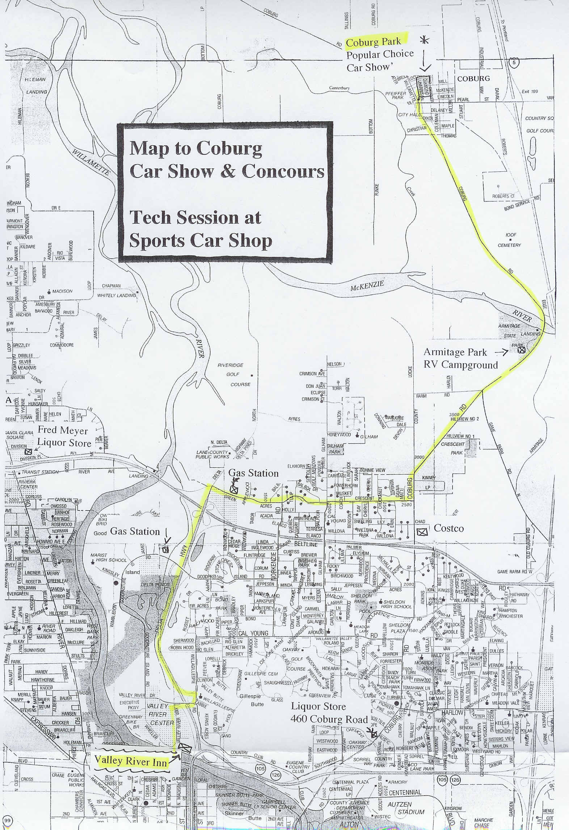
Helpful Hints:

Logo/theme: After the site has been selected, the logo and or theme of the meet should be decided. It is helpful to work closely with the company who has been selected to produce the regalia. This will insure that the logo can easily be transferred to the selected products. Sometimes the thread count and colors add greatly to the cost of the items.

Budget: It is a good idea to get an average of the number of participants from the past 3-4 years and what the registration fee was per person. This will be a quide in setting the amount per person for the registration fee.

The following is a list of the items that might be included in the budget: Trophies, ballets and signs, mailings, printing, site visits, bar set-up fee, park rental, picnic tables, credit card costs, committee shirts, etc.

Regalia: After the logo has been selected, decisions on the amount of regalia can be made. In order to maximize sales potential and minimize loses, the regalia committee should try to keep the number of separate items to a minimum.

Having pre-order only on the registration form is a good idea. A few extra items can be ordered for sale at the meet or for size exchange if needed.

The Rendezvous chair (s) may decide to have special shirts made for the committee heads. This is done to make them easily identified at the meet. These shirts would part of the regalia order.

Promotions: Start promoting the meet as soon as possible. Flyer’s can be made up and ready for distribution at the previous year’s meet. Notification can also be sent to regional clubs and national magazines.

Daily events: The meet generally starts on Monday with registration and a welcome party and ends on Friday with farewells. There is no set agenda for the meet, but typically the meet has a meet & greet night, car show, tours, auction, fun activities (funkhana, hot wheel races), tech sessions, afternoon tea for the ladies, regalia sales, arts and crafts.

Registration: One year out, have the registration committee develop a registration form. This form includes registration fee, car information, activities fees, pre-order of regalia, etc.

Have 3-4 committee members do a dry run at filling out the registration form. Have these members give feedback to the registration committee on questions they had while filling out the form. This helps to iron out any confusion with the form before the form is published.

Finalize the registration form and dispense to AH magazines, club web masters, at meets, etc.

Banquet: If a banquet is planned, have a table number sign-up sheet for table seating at registration. At the banquet, place the sign-up sheet on an easel outside the banquet room.
Nametags: Lanyards can be donated by major companies, i.e. Moss Motors.

Colored dots can be placed on the nametag to designate activities that have been paid for or tickets for those items can be placed in the plastic nametag pouch.

Daily event listing can be placed inside the plastic nametag pouch.

The name tag includes the following: Rendezvous dates and year, logo, registration number, name of registrant with their city\state.

Auction: January: create an announcement and send to AHCBC, AHCO, Golden Gate Club, San Diego Club and any other clubs in CA, Utah, etc.
Create the donation letter and mail out.

Make lists of received donations. (Many donations come in at the time of registration)

Just before the event, do a dry run through with your computer and printer.

Collect items during registration and start imputing the data into a master spreadsheet in Excel.

Separate the spreadsheet into live and silent items.

Estimating time for the live auction: assuming 4 minutes per item and 90 minutes total time for live auction would mean approximately 23 items for live auction.

Have items that have been celebrity signed in the live auction and include a good mix of quality handmade items and those that would bring the highest bids. Also include some fun items.

Type the registration names and numbers in Word, print them out on self-adhesive label forms.

The labels were attached to the file folders and stored in a hanging file type box, located close to the cashier, to have a place to store the winning bid sheet. Print a label for each item in the silent and live auction. These labels were attached to the bidder sheets, and then placed with the corresponding goods on the silent auction table.

This is the sheet that the participants would write their bid for that particular item on. Print a second copy of the labels to attach to a blank piece of paper to record the winning bid and amount. At the end of the silent auction, pick up the blank sheet with the winning bid and number on the tables with the goods.

Then transfer the winning bid and bidder number to the master sheet at the end of the silent auction to give the cashiers a master sheet to go with the cash.

Popular Choice Car Show: At least one year out, confirm the site for the car show. Be sure that there is enough space for all of the cars usually 80-100 cars. Also consider driving distance, traffic, construction, etc.
Having grass and shade for car display is nice. Also good to have restrooms close by and picnic tables with shade.
Get a signed contract. Have anything offered by the park officials added to the contract. For example, fee for park rental, time you start set-up, stage or microphone supplied, sprinkler system turned off, etc.

Get the cell phone number of the park contact person in case of emergency during the car show.

Concours Judging: Concours is supposed to be self-supporting. It is nice to have the concours judging done at a time that does not interfere with other events or activities.

The area for concours judging can be roped off from the general public.

Each entrant could be charged an extra fee beyond the concours fee. This extra fee would be used to cover expenses for the judges—i.e. drinks, lunch, etc. Also consider what the judges will need: cover for shade, pens, pencils, clipboards.

Below is a copy from the Austin-Healey Concours Registry Guidelines

Austin-Healey Concours Registry
Organization, Policies and Inspection Guidelines
January 2011
The Austin-Healey Concours Registry was created by members from a number of Austin-Healey clubs in North America to assist owners in restoring their cars to original standards and to encourage the restoration and maintenance of original cars. This publication outlines the purposes, organization, and policies of the Registry and describes Registry inspection and registration procedures.
Objectives of the Concours Registry
The objectives of the Austin-Healey Concours Registry are to:
• Provide information, assistance, and encouragement to those who wish to restore and maintain their cars to original specifications and quality.
• Certify and maintain a registry of those cars that have been restored to notable levels of originality.
• Encourage the continuing improvement of cars through a published and supported system of inspection, recognition, and awards.
• Establish consistent and widely accepted standards of condition and originality to assist in restoring cars and determining the quality of restorations.

(SNIP)
The following section is excerpted from page 9 of the document:

Inspection Guidelines
Meet Arrangements
There are two important aspects of holding a concours judging at an event. First there is the judging itself, and second there is making all the logistic and support arrangements at the site.

The organizers of a meet who desire to have Concours Registry inspections at their meet, the results of which would qualify for aware of Gold, Silver, or Bronze certificates, shall contact the Austin-Healey Concours Committee well in advance of the meet and request assignment of a Chief Judge. If the Committee can identify a qualified individual from among qualified, experienced judges, the Committee will provisionally sanction a Registry inspection, contingent on completion of inspection procedures for the meet that are acceptable to the designated Chief Judge. If the Concours Committee agrees to arrange an inspection at the meet, the meet organizers will then assign a concours liaison person from their organizing committee to work with the designated Chief Judge to arrange for the inspection at the meet.

It is the responsibility of the concours liaison, working with the other meet organizers, to make arrangements to include entry information on registration forms, to schedule the time and location of judges’ and entrants’ meetings and the inspection in support to the Chief Judge. In addition, the meet concours liaison shall also assist the Chief Judge by providing a list of planned attendees in advance so that any who have served as Concours judges in past years can be contacted for possible participation in that role, to secure necessary supplies for the inspection, and to support inspections at the meet, including scheduling and arranging for cars to be in position for judging during the inspection, providing lunches for all judges, and any other items that are needed.

It is the responsibility of the designated chief judge for the meet to secure a sufficient number of qualified judges to handle the anticipated number of cars, to brief the judges and owners in advance of the inspection, and to oversee the judging teams during the inspection.

Meet organizers should arrange for those who wish to have their cars inspected to register their intentions as part of registering for the meet. An entry fee, to be established by the Meet Registry Committee ($20 - $25 per car has been typical), should be collected by the meet organizers to defray costs related to the judging. These funds will be provided to the Chief Judge for allocation to cover costs directly associated with the judging. Such costs may include meals for judges, any special equipment (such as drop lights and clipboards) needed for inspection, and perhaps some tangible incentive for the concours team judges to donate a day of their time, such as full or partial reimbursement of meet registration fees, or a piece of souvenir regalia from the meet, as the budget will allow. These expenses and reimbursements will be paid from the entrant fees alone, and need not be drawn from general meet funds, unless fewer than three cars are entered for concours judging, in which case the Meet Committee will be asked to provide minimal financial support. Any funds remaining after inspection expenses are paid should be reimbursed to the Concours Registry Committee (after any Meet Committee contributions have been repaid).

Cascade Austin Healey Club of Washington
Lessons Learned From Rendezvous 2007
Compiled by Lois Buhman & Jan Saxon

Contracts: Take notes during meeting with anyone who will be supplying services for the meet. After the meeting, type up the notes, sends a copy to the person you met with and ask for them to initial them. This insures that you receive all of the services that were verbally promised. This is also helpful if the staff position changes. What one person verbally promises might not be passed on to the newly hired person.

Get the hotel under contract as soon as possible. For Rendezvous 2007, we were given an excellent guest room rate that we had locked in 18 months out.

Getting signed contracts also applies to catering and the park for the car show.

Registration Form: Decisions need to be made on the price of registration. Thought needs to be given to individuals. In other words if the registration fee is for two people is that fair to someone who attends alone?

Have the registration form ready for review of the entire Rendezvous committee over a year before the meet. At a general Rendezvous committee, pass out registration forms and ask each individual to fill out the form without asking questions. Hand the registration forms to the person who is in charge of registration for his/her review. Allow for people to ask questions about the form. The purpose of this process is to flush out problems before the form is finalized.

Add the Release and Waiver of Liability form to the registration for each person registering to sign.

Use a spreadsheet to tract the registration, regalia, and auction income and expenses.

Use a portable laptop computer, with printer, at Rendezvous.

Suggestions for improvement from the committee for Rendezvous 2007 were as follows:

1. Separate the Rendezvous registration from the events and regalia.

2. Use different fonts (BOLD, color, parentheses) to distinguish between US and Canadian prices.

Budget: We set the 2007 budget on a low predicted registration number, 115 we wanted to make sure that the club did not lose money on the meet.

We ended up with 130 people.

Having an auction usually assures that the club will make a profit on the meet.

Auction: Notes on silent auction: The table set up started at 1 PM with the auction room to be opened at 4:00 PM. We had 6 people helping us set up the room.

Lessons learned from the auction of the 2007 Rendezvous

Our timing did not work out well. People ended a tour at 4 PM and then went to dinner planning to attend the live auction at 6 PM. Holding the silent auction another night with more time for people to view and bid would work out better.

We suggest that the awards be given out some other night. It tended to kill the momentum of the auction and we found it took a while to get the people warmed back up for the auction.

At the end of the live auction have one person roam the crowd and accept offers on the zero bid items from the silent auction. This is done to clear out the items.

We had paddles made with participant’s registration number clearly placed on the paddle. This was extremely helpful in recording the bids.

We had two people to whip the crowd up and get the bids up. We had one main bid recorder and two assistant recorders in the crowd to keep tract of the live auction winning bid and amounts. It was really hard to see and hear so the recorders were a big help to cross check the accuracy of the bid amounts and the bidder number. It also gave us an extra list of go with the cash to give the treasurer at the end of the event. It also gave us an individual bid sheet to go in the winning bid file.

At the end of the auction, all the bid sheets for both the silent and live auction were in the individual files so we had a way to add up what each person owed and cash them out quickly. After paying, they would then go to the tables to pick up their treasures.

Golden Gate Austin Healey Club
Lessons Learned From Rendezvous 2009
Compiled by Loren Parks
1. Planning
Event planning should begin well in advance--at least a year is recommended. A strong promotion effort should occur at the preceding Rendezvous because that is the target audience.
We did not keep adequate pre-event meeting notes, which are critical for remembering responsibilities. The notes should be distributed to all members of the organizing committee immediately following the meeting.
Responsibilities should be dispersed as much as possible without losing organizational control.
Four couples stayed at the RV Park affiliated with the hotel. RV Parks should be identified in advance and mentioned in the promotional material.
2. Business orientation
The event must be approached with the objective of making a profit.
We didn't keep track of estimated total costs and revenues as they were forecasted and as they accrued. In future events the Treasurer should set up a spreadsheet with all actual and anticipated revenues and expenditures updated continuously. Everyone involved in spending money would report actual and expected expenses as they arise.
3. Organization and communication
It is important to establish and maintain a clear overall chain of command for Rendezvous within the Club as well as for each of its events. Similarly, the chain of command within the host hotel and other host organizations should be identified.
Communications could be improved among the event organizers by using Google Docs to share emails and other communications.

4. Registration
All events and prices should be completely defined and described before the registration form is issued to the public. Omission of some events from early versions of the registration form precluded making participation forecasts.
Before registration the packets should be as complete as possible. Packets should contain the printed program, lanyards, name tag holders, printed
nametags and placards for the car show, and advertising for specific events. This task was handled very well at Rendezvous 2009.
We did not have the ability to process credit cards, which probably did not affect last-minute signups for pay-events but which did affect regalia sales. That has been rectified with the Club signup for PayPal, which has Remote Terminal capability. Credit card processing should be set up at future events.
5. Vendor policy
We had no vendor policy, and a side deal was done without knowledge of all the Directors. A vendor policy should be defined early in the planning process and followed. It should also be promoted. The policy should state what constitutes participation, what constitutes the limits of participation, and the amount of the fee for participation.
The newsletter advertising manager should approach current advertisers for placement of ads in the Program. Two of our advertisers placed ads.
6. Regalia
The Club had leftover shirts and hats, which should not be allowed to happen again. Prepaid sales should be handled through the Club web site, which includes photos, prices, and payment by credit card. No speculative production of merchandise should occur. Regalia gifts for organizing committee members could be considered, as well as for auction and lottery items.
If a cloth logo is to be used on a hat, shirt, or patch it should be simple in design with few colors. In the vernacular of embroidery, it should not have a high thread count. The higher the thread count, the higher the cost.
Patches (for coats) are inexpensive if the "sublimation process" is used about $1.00 each. We gave one free patch with each registration, and additional patches were for sale. This was a good choice.

7. Event scheduling
The schedule was overloaded on some days-particularly the first day.
Participation in the Funkhana was adversely affected. Time must be allowed
to move from one event to another, and to complete the events scheduled.
8. Reception and theme
Establishment of a theme for the two large social events (reception and awards banquet) was successful, and it is recommended for the next Rendezvous. The Hawaiian theme worked well in spite of a location which had nothing to do with Hawaii. Live entertainment at the reception consistent with the theme (Polynesian dancing) was a great success; it was fun, and it established a good mood among the participants.
A good assortment of food with substance (i.e., meat) at the reception was successful; it contributed to the satisfaction of the participants. The cost was
successfully financed by taking a cut of the room fee, which was worked out with the hotel in advance.
Attendance at the reception was about 15% less than the registered number of participants due to late arrivals. At future events, it would be advisable to plan for at least 10% less than the number of registered attendees on the first night.
9. Registration and attendance forecasting
Early registration should be promoted vigorously to help forecast attendance. Forecasts must be periodically adjusted consistent with actual registrations. There are usually contracts with the host organization to provide for a specific number of people at each food event, and the fee is usually per person. Our experience was that it is better to add people than reduce at the last minute. The hotel is reluctant to cut revenues but eager to increase them.
No matter what we do there are people who cannot make a decision far in advance due to uncertainties in their schedules. A discount for early registration could be offered, but that might discourage late registrants which we a/so don't want to do. It is likely that we will have to promote early registration the best we can and live with the consequences.
There should be no uncertainty about who is responsible for making the forecast for each event, who will communicate the forecast and subsequent adjustments to the hotel, when the deadline is for finalizing attendance, and who is responsible in the Club and the hotel for making the deal.
10. Hotel Greeting
The greeting table in the hotel lobby was a nice hospitality gesture. A Hawaiian lei was provided to each person, along with explanation of where to find the registration room. This early contact with new arrivals is recommended for future events.

11. Funkhana
The Funkhana had sparse attendance, which we think was due to the number of simultaneous events and misunderstanding of how long it would take to complete the course. We did not explain well in the program how little time was needed to complete the event, and some potential participants might have abandoned it because of other events that morning. The total time allotted to the Funkhana should not exceed 3 or 4 hours, and the time needed for a couple to complete it should not exceed about 20 minutes.
The location of the Funkhana was not sufficiently convenient to encourage participation. It needs to be close to the hotel.
There was no charge to enter the Funkhana. An entry fee could be considered, but most of us oppose a fee because it might discourage participation. There could be a gift for each participant, but most of us are content with awards.
12. Fun Rally
This event was successful; no changes are recommended, which is testimony to good organization. The length of time required was about right-3 to 4 hours.
13. Arts, crafts and photography competition
The competition had a small but satisfactory turnout, and adds to the overall experience of the event. Our Club would do it again if someone is willing to take responsibility for organization and promotion.
14. Wine tasting tours
The two organized winery tours were completed successfully. Planning should begin far in advance to determine the best route and to understand the traffic flow. A maximum time of about four hours should be allocated for a tour. In addition, care must be taken to avoid overlap with other events.

15. Car show
Ironstone was an excellent venue, although the commute was longer than anticipated due to slow traffic and construction delay. Some people spent over 1.5 hours driving one-way.
It is essential that the car show organizer meet face-to-face and on-site with the host organization's manager to avoid ambiguity about what must be done, when it will be done, and who will do it. Telephone and email communications alone are insufficient.
It would have helped to have a PA system and walkie talkies available to the car show organizers.
The balloting system worked well. The car categories were appropriate. The system could be replicated at the next Rendezvous.
Classes: BN1/BN2 100 & 100M BN4/BN6100-6 BT7/BN7 3000 Mk I & II BJ7/BJ8 3000 Mk III AN5/AN6 Sprites
There was little viewing by the general public-due in part to lack of promotion. The principal problem, however, is that the show is held on a weekday when many people work. It would be appropriate to advertise the show locally if there are funds available. Advertising could be particularly effective when the show is held near an urban area.
16. Women's luncheon
The Women's Luncheon was not included in early versions of the Registration Form, and pre-event signups were consequently low. Attendance finally reached 27 thanks to ticket sales during registration. The concept of a participatory salad preparation with the chef was enjoyed by those who attended.

17. Evening restaurant reservations
Due to the limited number of restaurants in our rural location, some of the better ones were identified and contacted before the event to set up group reservations. People were able to sign up before the dinners, and our coordinator communicated with the restaurants. This was a successful venture.
18. Tours
The Sierra Passes Tour was a good route but too long for some participants. The last-minute decision to take Sheep Ranch Road to avoid construction delay elsewhere was regretted by some because of the roughness. Tour routes should be pre-driven to confirm length of time and the adequacy of signage, and should be followed as planned unless there is a compelling reason not to do so. Tours and rallies should be limited to about three hours.
19. Awards banquet
Individual awards for the driver and passenger are recommended instead of one award for both. The passenger should be awarded as "navigator" or "copilot."
The pre-event seating signup on a flipchart diagram of the tables worked very well. It should be replicated at future events.
The silent auction was financially successful, and should be encouraged at subsequent events by vigorously soliciting items for auction. The raffle was also financially successful, and should be limited to about 20 minutes so that it does not intrude on other activities.
The media presentation held during the Awards Banquet was a great success, and hopefully can be replicated if the talent is available to do it.

Oregon Austin Healey Club
Lessons Learned From Rendezvous 2010
Compiled by Charlie Frazer

Budgeting & Negotiating Rates
Develop a rational budgeting process and decide the role of the club versus planning committee in determining/managing finances.
The club treasurer helped me design a cost projection to break-even at 65 cars registered. Our club president required that the budget for the event be approved by a vote of the membership, and this was done. While the break-even analysis is essential, the budget approval process doesn’t seem very meaningful since once the club is committed to hosting the event, it is obligated to spend whatever money is necessary to do so. Ultimately, I spent more than twice the amount authorized, but I returned a significant profit to the club.

When you open negotiations with the hotel keep ALL aspects of the contract in mind. Our initial attention was focused primarily on the room rate charged to guests, but other charges added significantly to the cost of the event and could have been negotiated. For example:
Service or set-up charges for food and beverage service
Charges for AV equipment
Charges for meeting rooms
Charges for additional equipment such as tables, easels, lecterns, etc.

Put security in the budget. In Eugene, we paid $1500 to have two security officers in the parking lot dusk-to-dawn for four nights. This may not be essential everywhere but it’s important to protect these valuable cars when they are in a potentially vulnerable location.

Communications
At the beginning of the planning process, write a communication plan (what you’re going to do and when you’re going to do it) and stick to it.

Expect the AHCUSA to give publicity to the Rendezvous through AH Magazine, but get the editor’s deadlines and production specifications, submit your material on time and be sure to follow-up. Though our Rendezvous rally announcement was carried in AH Magazine in the Mar/Apr edition, the editor never ran four pages of ad material because “he forgot.”

Identify web masters/activity directors/newsletter editors from the other Rendezvous Council clubs early (but after annual elections) and build an email list.

Registration
Our registration was considerably beyond expectations at 132 (cars or couples, however you choose to envision it) compared to 77 in Jackson 2009 and 79 in Tri-cities 2007.

It is essential that the registration record is maintained on a computer spreadsheet that can be emailed to other Rendezvous Committee members on a regular basis. While the registration list is traditionally maintained in chronological order based on registration date, a spreadsheet allows other committees to sort the list based on their needs. Examples of the needs for this information include: Chairman—email addresses and phone numbers of registrants; Car show—numbers and models of cars expected; Regalia—merchandise ordered; Hospitality—number of meal tickets purchased; Concours—numbers and models of cars expected. This information is also vital to the organizers of the event in subsequent years and should be passed along to them.

It would be very helpful the have the registration spreadsheet on a laptop at the registration desk. This would allow adding walk-in registrations to the data base and recording the sale of activity tickets purchased on site.

Handling Cash
There are times during the event when it is necessary to turn over significant amounts of cash to the treasurer. Examples include walk-in registrations paid in cash, lunch tickets sold on-site at the car show, regalia sales, raffle proceeds and purchases at the auction. In order to keep adequate records all cash should be delivered to the treasurer in a sealed envelope with the name of the person turning over the money, the activity that generated it and the total amount noted on the outside. The Rendezvous chairman should receive the information as well.

Since the auction can run relatively late into the evening, be sure there is some provision for getting cash into safekeeping when the activity is over.

Tours
When we advanced the departure time of the Wed. tour with the intention of getting people back earlier in the afternoon, we inadvertently set both the Rally and the Thompson’s Mill tours at the same departure time. Simultaneous event departures are confusing and should be avoided in the future.

With the high event registration we had many cars on the tours (50 on Thursday!) and logistics became overwhelming. For the bridges tour on Thursday small pods of cars were dispatched from the hotel, each lead by a local driver. But, as latecomers joined the departure line, the dispatcher found himself to be the last driver remaining with 20 or more cars to lead.

While CB radios can be helpful in keeping groups together, they were not too effective in a group so large and spread out as the bridges tour. The committee cell phone list was of some help. ODOT didn’t help by tearing up roads that had been scouted the week before. For groups this large, detailed, up-to-date maps, cell phone lists for leaders and a contingency plan if the group becomes unwieldy all are necessary. Another alternative might be to run a sign up sheet with a fixed cut-off number. Alternative routes or destinations could be added based on demand.

Auction
The auction was a great success and generated over $5000 in revenue. This activity also requires considerable personnel support. The merchandise has to be solicited, cataloged and numbered beforehand, as well as moved into the auction room and set up. In addition to the auctioneer, spotters are needed to recognize bidders in the audience, with at least one person to record bids and registration numbers and another to handle payments. Pat Bolton developed a record keeping system using index cards to record participant registration number, item number and price, or this recording might be done on a laptop. It’s important to recruit people who are prepared to work at this for 3 hours or more until the auction is concluded.

Tickets
Rendezvous participants expect to be able to buy tickets for activities on-site. While it is desirable to include as may people as possible, particularly at meals, a reasonable cut-off date needs to be established. Participants should be notified of this cut-off either at registration or beforehand if possible.

We collected tickets at most events, but not at the Awards Dinner. Given the cost of this event and the price participants paid to attend, we should have made sure everyone who got a plate had a ticket.

Though it’s hard to know exactly how many tickets were sold for each event since on-site ticket sales weren’t always recorded, the best estimate is as follows: Car Show BBQ: 213, Ladies Luncheon: 44, Awards Dinner: 185.

Car Show
The Rendezvous Committee should decide early if the Best of Show award will be determined at the car show, or selected later from among the winning cars in each class. If voting is at the show the BOS ballot can be included in the ballot packet. If BOS is determined later a separate ballot and voting procedure is necessary.

Car show organizers should determine if cars need to be staged by class for departure to the show site. If so, identify the dispatcher and the class leaders and assign departure times. Post the times in advance or include them in the registration packet.

Concours
Holding the Concours judging at the same time and location as the car show was a mistake. People wandering through the judging are distracting to the judges and owners and can inadvertently interfere with the process. If necessary, rope off the Concours area.

The Concours coordinator needs to communicate with the chief judge before the event to determine start time, location and ground rules and should communicate this information to entrants. Expectations about support for the judging should also be determined beforehand. Examples of support could include sun/rain shelter, score sheets and clipboards, pens & pencils, calculators, refreshments, lunch, special regalia and area security.

The relationship between the fee charged to Concours entrants and the costs of putting on the judging should be considered in advance by the planning committee. For example, will the people planning lunch for Car Show participants be expected to provide lunch for Concours judges and participants?

Audio-Visual Gear
Relatively sophisticated and expensive A-V gear has become the expectation not only for evening events, but for presentations and tech sessions as well. Macs, amplifiers and speakers, computer projection equipment and screens can quickly add hundreds of dollars to the cost of an activity when supplied by the hotel. If this equipment is to be borrowed from club members or other participants, it should be assembled and operated in the configuration in which it will be used well before the start of the event to allow for trouble shooting, obtaining correct connectors and adapters, configuring software, etc.

Miscellaneous
Decide early what to do with comp rooms.
We converted complimentary rooms into event revenue by selling raffle tickets, once we surpassed our minimum room guarantee. We made about $600 raffling off two complimentary suites, but we could have made more money if the raffle had been better publicized and tickets sold more aggressively.

Put your event logo on everything you print.

Make lots of signs.

Having the greeters out front during registration was a good idea that set a friendly tone for the event.

Display special regalia at the registration desk and give clear directions to the regalia sales location.

Austin Healey Owners Association of British Columbia
Lessons Learned From Rendezvous 2012
Compiled by Don Manning


Austin Healey Owners Association of British Columbia
#602 - 1641 Lonsdale Ave.,
North Vancouver, B.C.
Canada, V7M 2J5
www.healeys.ca

July 14, 2012
Cascade Austin Healey Club of Washington Austin Healey Owners Association of B.C.
Attention: Jan Saxon and Lois Buhman Attention: Sarah Sanderson-Wilson
Dear Jan and Lois Dear Sarah:
Re: Rendezvous 2012 Review/Rendezvous Guide
The purpose of this report is to report on the results of Rendezvous 2012 to both the host club and the Rendezvous Guide.
First, I would like to thank the Cascade/AHOABC members who worked on the delivery of Rendezvous this year. I appreciate the cross border component of Rendezvous. Even though we live in different countries, this relationship really makes Rendezvous a true International event, not only as participants, but as part of the delivery of the Meet. In particular, I want to repeat my thanks to Steve Day, Phil and Beckie Daniels and the Saxons for “coming to the plate” when we reached out for help.
Our club, although relatively small, appreciates the opportunity to deliver Rendezvous and play our part in carrying on the tradition of what began as the West Coast Meet and what is now known as Rendezvous.
I am including the following with this letter, all of which I hope will be taken as constructive:
- Rendezvous Committee Comments from our last committee meeting on July 5, 2012
- Some of my personal comments on the meet
- Some personal comments/suggestion the Rendezvous Guide
If you have any questions or concerns, I will be happy to address them.

Respectfully submitted

Don Manning
Chair, Rendezvous 2012

Rendezvous 2012 Committee Meeting, July 5, 2012

Several of the Meet committee attended the meeting, including:

Michael De Wilde – Sponsors
Brian Drab – Registration and Web Site
Andy Jones – Car Show/Car Wash
Mike Long – Car Show and Regalia
Karen Manning – Ladies program
Karen Morrison – Food and Beverage
Jim Morrison/Elaine Grenon – Live and Silent Auction
Adrian Percival – Regalia and Awards
Karen Percival – Registration packages

The committee met to review our respective comments on Rendezvous this year, as follows:

Registration
The meet was scheduled to begin on Monday, June 25. A significant number of people arrived at the venue on Sunday, June 24, many of whom were expecting to register immediately. Question: Should registration start on the Sunday? Response was no, as the committee needed to ensure the venue was ready and events were set to go on Sunday and Monday, let alone set up for registration on Monday.
The registration desk can be set up on the Sunday with an notice advising when registration will commence, and should advise attendees are on their own on Sunday.
(Personal comments: Story board at registration desk was a good idea, a notice at the registration desk would be a good idea on Sunday. The location of the registration desk worked out well as it was proximate to the check in and in a central area.
We were successful in securing quality lanyards from a meet sponsor, Hagerty Canada. Brian Drab developed quality meet labels, including printed symbols to enable prepaid events to be managed efficiently.)

Get Together - Monday
The get together worked well, the food presentation was excellent.
(Personal comments: We wanted to open Rendezvous with a good impression so be budgeted for that. We hosted the first drink, after that there was a no host bar. The Resort provided us with drink tickets, which were used to bill us for the first drinks. We decided to promote our sponsors at each major event, and a group picture was take and forwarded to the Monday sponsor, who had donated ball caps for distribution. As noted later in this report, sponsors proved to be important to success. We were fortunate to have Michael De Wilde on board, who did an outstanding job of securing sponsors for the meet. This proved to be a successful strategy and we found that we were able to secure significant sponsors, who we promoted on our website and on our Facebook page for the meet. I recommend that future meets consider securing sponsors as it takes pressure off the revenue collected from attendees.)

Photo Session
Beckie Daniels volunteered to photograph each car/owner(s) in a staged location on site. Net proceeds were contributed to the Meet revenues. This worked well and was well received.
(Personal comments: This activity and location would be best organized in advance. As part of our organization, we asked Andy Jones to coordinate with the property for the Car Show and car wash., as well as this event. This decision worked well.)

Tech Sessions
The feedback from the committee was positive for the tech sessions.
(Personal comments: We approached Steve Day of British Car Ranch some time ago to spearhead the tech sessions, and he was positive from the beginning. We ended up with delivery of indoor and outdoor tech sessions on Tuesday, Wednesday and Thursday, resulting in more tech sessions than what had occurred for many years. Each tech session was well attended, and Steve took a proactive position by including others from the Healey community to help, including B.C. members Earl Kagna and Mike Long. Steve also delivered the ladies tech session, which was well attended. Steve found the whole experience very rewarding for himself and I would recommend him to any future meets. Steve also has other skills, including auctioneering and auction spotter, and is a valuable resource. The fact that every tech session was well attended tells me that tech sessions have merit for future events and that future meets should not be afraid to offer tech sessions that are not strictly attuned to mechanical/electrical sessions, and they should be kept relatively informal to attract interest.
Mark Schneider approached us with a proposal to deliver a photo tech session, which we scheduled for Tuesday morning, before the Car Show started. This session was well attended, and the feedback I heard afterwards tells me that there is demand for future sessions.)

Ladies Program
Karen Manning organized and coordinated the ladies program. The primary event was a ladies only spa event at the resort.
There was feedback that the ladies program had the positive effect of enabling the ladies to get to know one another, but there was concern that the spa event conflicted with one of the tours.

Car Show
The feedback on the car show was that it was well organized, there were positive comments on having it on the venue site, as it provided the opportunity to those not interested in the car show to have freedom of movement that would not be the case at a location off site. Beckie’s photo session was held prior to the car show, which also worked well and people marshalled themselves quite efficiently for the photos over a time period of an hour or so as they were ready to be photographed. Beckie organized herself with respect to the photos using registration numbers.
The lot should be planned out, in advance.

A rep. for the car show should be at the registration desk to handle questions and issue last minute cards and info for people who want to be in the car show.
(Personal comments: It was a good decision on Andy Jones’s and Mike Long’s part to come to the venue in advance of the meet to coordinate with Hotel personnel with regard to the layout. I think this eliminated many potential issues as the Hotel really did not know what to expect. We had initially wanted the Car show at a different location on site, but that introduced additional costs for the BBQ. The Hotel came up with the BBQ location, and that worked well in conjunction with the Car Show. The car wash was entirely self-serve and was located proximate to the Car Show location, and worked well. It is interesting to remember the social aspect of this event, as people congregated as they wished, including a reasonably large gathering point where several attendees brought their folding chairs and congregated. The hotel provided us with a car wash area in the main parking lot, which worked with little if any problems.)

Signage
The feedback on the signage was positive.
(Personal comments: We used a collection of professionally made board signs that date back to the car show at Expo ’86 that were given to us by the Expo ’86 people. We updated these with the Meet logo. We also had signage made up on board using the meet logo to direct people to the site and for use at the venue. Use of lots of colour and signs that can be mounted and seen for people to see it is recommended, with arrow signs where appropriate. At the auction, these signs were auctioned, with the exception of one which was later presented to Dan Doucette, who designed the Meet Logo. I would recommend that the logo be designed well in advance keeping in mind the Meet theme, which in this case was the 60th Anniversary of the introduction of the Marque.)

Scheduling of Live Auction/Related items
The live auction was originally planned for Thursday and was rescheduled to Tuesday for reasons of maximizing attendance as well as to avoid overloading the Banquet evening with activities. This proved to be the right decision, and was scheduled early enough in the evening for people to attend and then have dinner on their own, with the effect of making the Tuesday evening event more workable.
It was recommended that items should be available at checkout with a “runner” employed to make sure auction winners receive their items after payment is received.
(Personal Comments: Elaine Grenon and Jim Morrison teamed up to deliver a successful auction, both in presentation and in tracking the results. I appreciate their attention to detail, as well as their flexibility in last minute changes behind the scenes. They were absolutely correct in their recommendation to move the live auction to Tuesday from Thursday, as well as encouraging that the items auctioned be limited. With respect to attendees donating items, I recommend that the registration process include a request for people to tell us what they want to bring. Registration forms should also encourage people who want to donate something to give some thought to donating auction items that will create some interest. Finally, there were some very generous donations made by some to the auction, from both sides of the 49th Parallel. An example of this is the donations made/acquired by the Lamb’s. I would recommend that future meets consider recruiting one person living in the U.S. and one from Canada to search out quality auction items. The fact that we were successful in attracting quality auction items shows me that there is demand for such items, and the result ensured the financial success of the meet. We were fortunate that one of our members, Phil Daniels, who lives in Washington State, was able to source auction items and in the case of the exhaust donated by Moss, keep it at his home in the event that a U.S. registrant won the auction for this item, which proved to be the case.)

Silent Auction
The silent auction was originally scheduled to run concurrently with the live auction. A decision was made during the meet to extend silent auction bidding to Thursday night by putting the silent auction items on display in the regalia room. This worked out well. Restricting items (in our case to 38 items) worked well. Posters seemed to be best suited to the silent auction.

Regalia/Registration
For logistical reasons, Registration was held Monday – Wednesday, near the hotel check in. Regalia was housed in a meeting room on the lower level.
There was feedback that regalia and registration should be in a more prominent room than was the case and should run concurrently and together.
The committee felt that preselling regalia was a good idea, however, the ordering of regalia during the meet was not recommended for future meets.
(Personal comment: We were fortunate in having the abilities of Karen Percival to marshall volunteers and lead them through registration. This is an important issue as these people are often the initial contact for attendees. We closed registration by Wednesday, with little if any problems resulting. Similarly, Regalia closed on Thursday, again with little or no issues resulting. One thing we did this year was to order meet pins for each attendee, which we attached to each lanyard prepared for the meet. This had an unexpected result: The pins as well as the ball caps donated by our Platinum Sponsor, Frederique Constant Genve, became a reminder/souvenir of the meet for each attendee, which will remind them in future of the meet.)

Tours
Recommendations:
- There should be a pre tour meeting for each tour.
- There should be two tour leaders
- The tour duration was endorsed.
- Directions handed out should be proofed as there were errors in the handouts.
- Tours should be made more “lady friendly”, i.e. less “aircraft”.
- There should be optional itineraries.
- The lunch spots were well received.

(Personal comment: My personal thanks to Chris Poole and Bryan Treen for their efforts in planning and delivering the tours, which were held on Wednesday and Thursday.)

Pub Night
The Pub Night (Wednesday evening) was set up with the owner of a local British Style Pub in advance of the Meet. This did not work well as the Pub staff were not prepared for the size of the group on our arrival.
Recommendation: Future events such as this, if held, should be booked on a contract basis, arrival times should be staggered and the Pub should commit that it has the ability to handle the numbers of people. This Pub had seating inside/outside but the serving staff and the kitchen were unprepared, even though we had told them to expect approximately 150 people.
(Personal comment: If a future meet decides to have such an event but does not wish to commit to a contract, other options such as an open evening or going to a large venue, such as a theme park might be a better option.)

Wind Up dinner
Comments:
There were sufficient bar stations. This should be considered for future meets,
Stay away from “tacky” decorations
Having no entertainment was a “plus”.
Having multiple MC’s was seen as positive.

Awards
The awards were very distinctive (Custom made pewter mounted on a wooden base) and well received.
(Personal comment: As in previous meets, Adrian Percival did an excellent job of sourcing and creating the awards.)

Sponsors
(Personal Comment: We were fortunate to have in Michael De Wilde a committed leader for seeking, acquiring and thanking sponsors, before, during and after the meet. The funds generated were of great assistance in ensuring the solvency of mounting Rendezvous. This has been followed up by acknowledging the sponsors at the main events as well as follow ups following the meet in communications and by forwarding copies of the “Wings” commemorative issue. A side benefit is that we hope to keep at least some of them as advertisers in “Wings”.)

Acknowledgement of the Venue
It was decided that Tigh Na Mara be acknowledged for their assistance in mounting this meet. Accordingly, I have prepared and delivered a “thank you” letter, as well as an “In Appreciation” award to Wendy Johnson at Tigh Na Mara. At their request, I have also posted feedback for them in Social Media.

Registration and Administrative Hints/Recommendations
These are my personal comments:
Registration data entry and tracking is a big job, and we were fortunate in having Brian Drab organizing and coordinating this. We also need to thank Michele Karatnyk for developing a searchable database so that we could keep track of people, events, and regalia. My recommendation is that the Registration form should be ready no later than October 1, as later opening of registration creates unexpected problems, including people contacting the venue before we are ready to take registrations.
I do recommend that:
A budget should be prepared at the outset one attendance goals are set and the venue is selected. In our case, we relied on past meets for guidance and developed a monthly projection of cash inflow and cash demand, on a cash basis. Each province or state have their own taxation requirements (if any), and this must be accounted for in the cost of events. In B.C. currently that figure is 12% HST. If nothing else, the budget will assist in determining pricing for events where money needs to be collected.
Registration and Regalia ordering be as much as possible offered “on line”, and not with paper registration. Doing this speeds up the process and the collection of funds. For this to work, the treasurer of the club and the person processing registrations need a system to coordinate incoming funds to registrations so that each registrant receives what they have requested and funds are properly tracked and accounted for. This worked will between Brian Drab and Lawrence Robertson, our treasurer.
Payments should be in the currency of the country in which the meet is being held.
Both Visa and Mastercard should be accepted, if possible and settlement of credit cards be made in the currency of the country where the meet is held. I do not recommend that cheques be used at registration, particularly in a cross border setting.
A firm refund policy be adopted and published in advance to deal with last minute cancellations.
A website for the Meet should be used, as much as a management tool as an information tool. In our case, a running, password protected registration spreadsheet was available for the committee to use on line to plan the meet. This enable the people who needed to know the means of determining answers to questions of numbers so that they could plan in their respective areas of responsibility.
The website is also a good means of informing people before the meet of news of the Meet and what is planned. In our case, we found that scheduling had to be adjusted periodically, and this is a way of informing registrants of those changes. I would recommend in future investigating the viability of “push” technology to inform clubs and registrants of things that are happening. In addition, Michael De Wilde maintained an e-mail list for clubs and attendees to advertise and promote the meet, and this was beneficial.
In short, these meets need to be actively marketed to encourage as high an attendance as possible. Organizers have to be proactive in spreading the word as the number of active people declines over time.
We also created a Facebook page for marketing and sending out news of the meet. I think this can be developed further. It is clear that the sponsors appreciated the exposure we provided to them on this page, as they track such activity, but many attendees are not at this point confident in or supportive of getting involved with social media. By the start of the meet, there were 50 “friends” following the page, or about half of the number of cars who registered.
That registration be geared to the number of people attending, and not the number of cars. This makes it easier to budget food and beverage costs of mounting the meet.
Hotel bookings should not be permitted until registration is complete. This can be accomplished by creating a booking code with the host hotel. The reasons for this are that the host club needs registration funds to pay for many “up front” costs of the meet, as well as to recover registration fees in any event from each attendee. We found that by providing the hotel booking code prior to registration to certain people created confusion and it is very important that the venue and the host club be on the same page. We overcame this by arranging for the venue send us their bookings list every two weeks, enabling us to match against the registration list. The only problem we had was that we did not know who some of the hotel registrations were and had to track them down in order to get them to register. This can be avoided by requiring registration before booking.
I would like to express my appreciation to our club in providing the seed money needed to provide the deposit required by Tigh Na Mara. As Lawrence’s financial summary will show, these funds have now been returned to the club.

Negotiations with Venue
These are my personal comments:
We negotiated room rates in advance with Tigh Na Mara and they held to them. We did not appreciate however that while they set aside specific numbers of rooms/cabins/townhouses for the meet, that did not include all rooms in the property. Some registrants had to pay in addition to the rates provided to us because the accommodations they wanted were not in the room pool set aside for us. I believe the reason for this is that the rooms are privately owned and some of the rooms are of a “premium standard to some of the others.
Deadlines were set by Tigh Na Mara for cancellation costs and deadlines for cancellation. This needs to bourne in mind so that needless expenditures are avoiced.
We agreed to pay for some of the meeting rooms set aside for us. This is a revenue source for the property, so asking for free rooms only results in being charged somewhere else to recover that revenue.
It is a definite plus for someone familiar with food and beverage to negotiate menu choices and other relevant issues with the Hotel Food and Beverage Department. I must that Karen Morrison for her imagination as well as focus on detail. I know that the property learned from this experience and the suggestions that Karen made to them. I was impressed by the method used by Karen to monitor the numbers attending the Barbeque on Tuesday – count the number of napkins/cutlery handed out to each attendee. This enabled us to make sure we were charged for the correct number of people attending the Barbeque. A similar simple but effective method was used for tracking the first drink paid by the club for the get together – a pre-printed card prepared by Tigh Na Mara.
Karen Manning was similarly able to negotiate an enjoyable ladies program with the Spa.

Importance of the Meet Committee
These are my personal comments:
Meets are not the creation of one person, they are the product of the contributions over an extended period by a committed group who each want to contribute in a tangible way.
By nature, this is a voluntary process and the planning process depends on the interest and personal schedules of each member. It is important to bring in people who can be delegated areas that they are interested in developing. By doing this, there is more commitment from each.
This is the fourth time I have chaired West Coast Meet/Rendezvous. Many of the people on the committee have been doing this for as long as I. Because of this history, no one is timid about expressing their opinions on ideas that come to the table, and that input pretty much proves out to be absolutely correct.
I appreciate the commitment and contribution of each member of our committee as well as all those who pitched in when their help was needed. Thanks to everyone who participated, and, thanks to those, including Brian Drab, Karen Morrison, and others, who told me what needed to be said, when it was needed.

Acknowledgement of Austin Healey Club USA
These are my personal comments:
Even though our club is not directly affiliated with any US umbrella body, Rendezvous is a sanctioned event of Austin Healey Club USA. This year, Mark Schneider is the President of AHCUSA, and I would like to acknowledge his input and support of our efforts, which were always available to us. I hope in future that this can be replicated with future meet chairs and the AHCUSA.
Respectfully submitted

